ESF – TTORCH Short Visit Grant
Application Reference N°: 6603

Eddy-covariance fluxes of methane from a permafrost ecosystem: Linking measurements across spatial scales and detecting environmental controls

Travel time: 02. - 18. July 2014
Grantee: Fanny Kittler, Max-Planck Institute for Biogeochemistry, Germany
Host: Sergei A. Zimov, Northeast Science Station Cherskii, Russia

Purpose of Visit
High-latitude permafrost landscapes contain a massive amount of organic carbon, but their response to future climate change is still highly uncertain. Improved understanding of high latitude carbon cycle processes is critically important, particularly concerning the role of non-CO₂ trace gases like methane. To address this issue, we established a new observation site near Cherskii in North-eastern Siberia (68.75°N, 161.33°E). In this tundra ecosystem, recent carbon flux patterns and long term trends in carbon fluxes (reference data available for 2002-2005) can be studied for both natural and disturbed (drainage ditch ring installed in 2004) conditions.
Recent investigations started in July 2013, with a strong focus placed on the year-round observation of CH₄ fluxes using the eddy-covariance technique. The first major objective is to detect long-term trends in methane emissions, including the evaluation of the net impact of a decade-long hydrologic disturbance on greenhouse gas budgets. Secondly I will evaluate the spatiotemporal variability of ecosystem-atmosphere exchange fluxes in arctic permafrost regions as well as the environmental drivers that dominate this variability.

Description of the work carried out during the visit
Beside observation maintenance and upgrades, the field trip planned for summer 2014 focused on:
- Collecting data on ancillary environmental drivers that influence the eddy-covariance methane fluxes
- Ground-truthing of regional scale remote sensing maps to prepare a data-driven upscaling study to link local fluxes to results from regional scale atmospheric inverse modelling (see Figure 1).
- Assisting in the collection of chamber flux data and ecosystem characteristics in the fetch of the eddy towers, which will be used to link eddy-fluxes to small-scale (1-5 m resolution) variability through local scale transport modelling (footprint analysis).
Day 1 - Day 3: General inspection of eddy-covariance towers and planning of the required maintenance
Day 4: Flux measurements of CO₂ (including net ecosystem exchange and ecosystem respiration modes), CH₄ and H₂O at 4 small chamber locations and 2 big chamber locations. Additional plant-mediated transport was measurement at the small chamber sites.
Day 5: General maintenance of one of the eddy-covariance towers, including cleaning of the sonic anemometer, inspection and re-arranging of temperature profile sensors, inspection and re-installation of additional sonic anemometer, re-arranging precipitation sensors, repairing of soil moisture sensor and improvement of snow depth sensor.
Day 6: Data collection for assessing lateral carbon export through drainage channel, including dissolved organic carbon sampling, water isotope sampling and dissolved gas analysis (CO₂ and CH₄) at 6 locations. CH₄ flux measurements with floating chamber at 3 locations.
Day 7: General maintenance of the second eddy-covariance tower, including cleaning of the sonic anemometer, re-arranging of precipitation sensors and repairing of soil moisture sensor. Furthermore the open-path gas analyzer was disassembled. Inspection of the closed-path systems for mixing ratios of CO₂, CH₄ and H₂O at both towers with leak tests, pump test and cleaning of filters.
Day 8 – Day 10: Validation of remote sensing maps by ground-truthing selected points and describing the area in terms of homogeneity, wetness, vegetation composition and vegetation height. Ebullition events of methane were measurement at 4 locations with small chambers.
Day 11- Day 13: Processing of collected data, with a special focus on the environmental parameters collected during the chamber measurement campaigns. Preparation of detailed documentation to be used by collegues from our institute who take over site maintenance and data collection in the weeks following my departure.
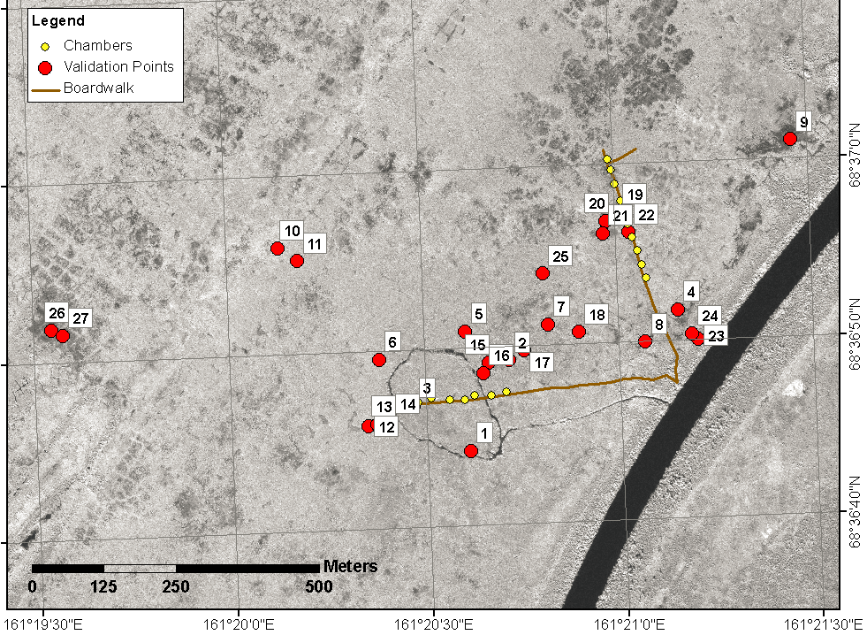
Figure 1: Validation points for ground-truthing of remote sensing maps.

Description of the main results obtained
The general maintenance tasks performed on the eddy-covariance systems during my site visit significantly improve our chances to collect high-quality measurements of ecosystem-atmosphere fluxes of carbon (CO₂ and CH₄) and environmental parameters over the coming months. Final results cannot be present here because of ongoing upgrades in our data-processing scheme. Environmental parameters were collected and processed (conversion in physical units, quality filtering and averaging).
During my site visit, a broad variety of weather conditions were observed, resulting in very different measurement conditions. A general overview of environmental parameters and the resulting weather situation is displayed in Figure 2. The first part describes a cold, cloudy and rainy period. This weather condition can be observed with northerly winds, when the weather is influenced by air masses that transport humid and cold air from the Arctic Ocean towards the mainland and cause precipitation events and closed cloud cover. Following this period we experienced a time with mostly clear skies, long hours of sunshine and increasing temperatures. This is caused by a change of the wind direction towards south with continental (dry and warm) air masses. The third period represents an unusually hot period, which brought along more cloud cover, but no rain. During the last period the weather was influenced by northern winds again, with a strong decrease in temperature and precipitation events.
For the validation of the remote sensing maps a list of diverse locations across our observation site was examined (see Figure 1), with general features of each site summarized in Table 1. These results will facilitate a through quality-checking of land cover classification maps based on highest-resolution satellite remote sensing datasets (WorldView). The resulting maps will provide a central piece of information for the interpretation of eddy-covariance flux measurements, e.g. for determining the composition of vegetation elements (wet/dry microsites, grassy/shrubby vegetation, etc) in the field of view of the sensors through footprint analyses, or for more precise upscaling procedures for the measured fluxes. First results show that the micro-scale heterogeneity is very high and the vegetation and humidity can change within a few meters depending on the terrain height.
The processing and analysis of the data collected with the small as well as big chambers, the isotope samples, water samples and dissolved gases probing will be conducted as part of ongoing PhD and MSc theses. It is expected that methane ebullition events take place preferably during time of changing pressure and higher wind speeds. During my field stay, in total 4 periods with favorable conditions for methane ebullition could be identified (see Figure 3), and indeed it was possible to observe some events within these periods in the field.
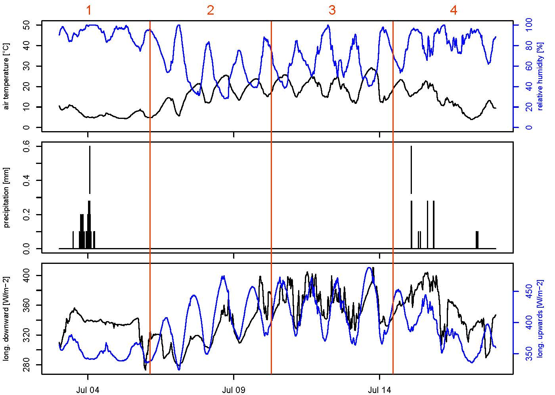
Figure 2: Selected environmental parameters to describe the weather situation. The plot at the bottom displays the two components of the longwave radiation. The weather during the whole time can be divided in 4 different parts, marked by the red vertical lines and numbers.

Table 1: Description of vegetation composition as well as height and additional site characteristics for all validation points.
ID | 2 m description | Veg height | Other notes
1 | Dominant: cotton grass  Cotton grass, tussock, willow shrubs,  Flowers (white << purple) | Shrubs < 2m  Tussock 30-40 cm  Flowers 20-30 cm  Cotton 20-30 cm | Wet = 2  Homo = 2
2 | Dominant: tussock with cotton grass both with  Brown/gray leaves + a few shrubs | 30-50 cm | Wet = 1  Homo = 3
3 | 50:50 tussocks:shrubs  tussocks, shrubs, few cotton grass  several flowers (purple, pink, white) | Tussocks: 30-40 cm  Shrubs: 40-60 cm  Cotton grass: 30 cm | Wet: 4  Homo: 1
4 | Dominant: cotton grass with white/brown  Dead parts, white blossoms | Cotton grass: 40-50 cm | Wet: 1  Homo: 5
5 | Dominant: tussocks with white/brown parts.  Rosa flowers, shrubs | Shrubs <= 1 m  Small tussocks: 30-50 cm | Wet: 2  Homo: 4
6 | Dominant: tussocks  Tussocks, shrubs, purple flowers,  Cotton grass | Tussocks: 30-50 cm  Shrubs < 2 m  Flowers, cotton grass 20-30 cm | Wet: 2  Homo: 1
7 | Dominant: cotton grass, aprox 30% white/brown  Dead parts, some alone tussocks | Cotton grass 50 cm  Tussocks 40 cm | Wet: 1  Homo: 4
8 | Dominant: Tussocks  Tussocks, beech, willow, edge of shrubby patch | Shrubs: 2,5 m  Tussocks: 40-50 cm | Wet: 3  Homo: 1
9 | Dominant: grass  Light brown (dead) | 30-40 cm | Wet: 1  Homo: 5
10 | 50:50 tussock:shrubs  tussock, shrub, cotton grass, pink flowers | Same as Point 4 | Wet: 1  Homo: Point 6
11 | Dominant: tussocks  Shrubs, tussocks, purple flowers, cotton grass | Tussock: 30-50 cm  Shrubs < 2 m  Cotton grass: 20-30cm | Wet: 1  Homo: 2
12 | Dominant: tussocks  Shrubs, tussocks, pink flowers | Tussocks: 30-40 cm  Shrubs < 2m | Wet: 2  Homo: 3
13 | Dominat: tussock  Shrubs, tussocks, few cotton grass, several flowers (pink) | Tussock: 30-40 cm  Shrubs < 1.5 m | Wet: 2  Homo: 2
14 | Dominant: 50:50 shrubs, tussock  Shrubs, tussocks, cotton grass, several flowers (purple) | Tussock: 30-40cm  Shrubs: 40-60 cm  Cotton grass: 30cm | Wet: 2  Homo: 1  12.07.2014 17:30
15 | Dominant: tussock >= shrubs  1x small white flower, 2x blue flower, < 10x purple flower between tussocks, moos,  cotton grass | Tussock, grass: 30-40 cm  Shrubs <= 1m | Wet: 4  Homo: 4  12.07.2014, 18:11
16 | Dominant: tussocks (with white/brown dead grass)  Cotton grass, shrubs, 1x rose flower,  1x small white flower some shrubs |  | Wet: 2  Homo: 3  12.07.2014, 18:27
17 | Dominant: cotton grass (~ 10-20% dead/brown/white grass) >= tussocks  Some shrubs | 30-50 cm | Wet: 1  Homo: 3(2)  SW shrubs, N really no shrubs
18 | Dominant: tussocks >= cotton grass with brown/white parts | 30-50 cm | Wet: 1  Homo: 4
19 | Dominant: tussocks  No grass, old tussocks (leaves are brown)  Birch dominant | Shrubs: 70-80 cm  Willows < 100 cm  Tussocks: 40 cm | Wet: 2  Homo: 1
20 | Dominant: grass  Light brown (dead) | 30-40 cm | Wet: 1  Homo: 1
21 | Dominant: grass, homogeneous  Light brown (dead) | 30-40 cm | Wet: 1  Homo: 5
22 | Dominant: grass  Light brown (dead) | 30-40 cm | Wet: 1  Homo: 5
23 | Dominant: shrubs  Dead tussocks (light brown) | Shrubs < 2 m  Tussocks: 10 cm | Wet: 4  Homo: 4
24 | Tussock, willow, cotton grass  Undefined (Picture 2549) | Cotton grass: 30-40 cm  Tussocks: 40-50 cm  Shrubs < 2m | Wet: 2  Homo: 1
25 | Dominant: tussock  Cotton grass, some shrubs (ca. every 2m) | Tussocks: 50 cm | Wet: 3  Homo: 3
26 | Dominant: cotton grass  Few tussocks | Cotton grass: 30-40 cm  Tussocks: 30-40 cm | Wet: 1  Homo: 5
27 | Same as 26

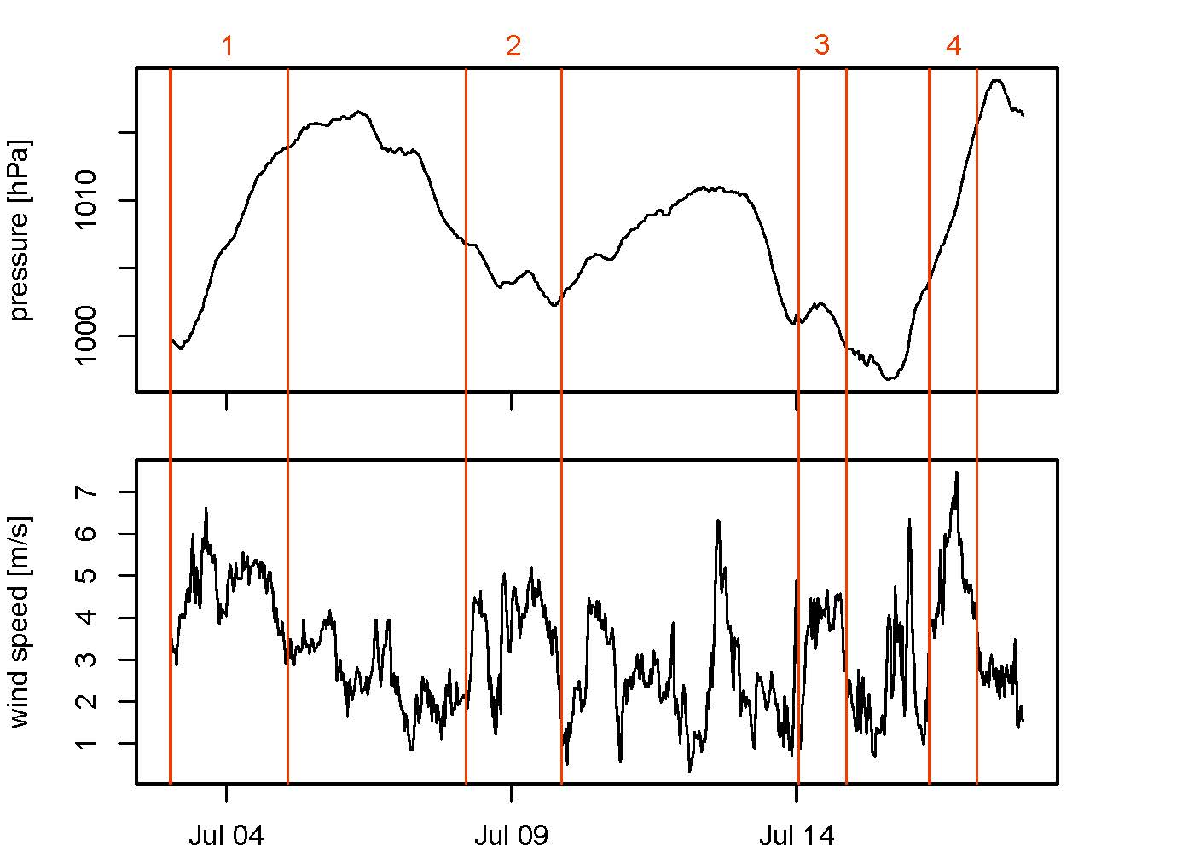
Figure 3: Identification of periods with air pressure and temperature conditions that are favorable for methane ebullition events. Highest probability during 4 periods, marked with red lines and numbers.

Future collaboration with host institute
Investigations at our field site near Chersky started in July 2013, and focus on the year-round observations of carbon exchange fluxes between biosphere and atmosphere. The project is supposed to continue at least until 2017. Within this framework, a close collaboration with the host has been agreed on, and both sides expect to continue with this collaboration for further years beyond the current contracts.

Projected publications / articles resulting or to result from the grant
First results of this field work campaign will be presented at the AGU (American Geophysical Union) fall meeting 2014 in December 2014 in San Francisco. Thereby the composition and weighting of environmental drivers that dominate the turbulent exchange fluxes, dependent on the disturbance regime, will be discussed. Furthermore the results from the site visit will be used in planned publications about “Long-term effects of hydrologic disturbance on the fluxes of carbon and energy in a permafrost ecosystem”.

