|  |  |
| --- | --- |
| **esf_green_logo** | **Research Networking Programmes** |
|  |
|  |

**Short Visit Grant**  **or** **Exchange Visit Grant**

***(please tick the relevant box)***

**Scientific Report**

**The scientific report (WORD or PDF file – maximum of eight A4 pages) should be submitted online within one month of the event. It will be published on the ESF website.**

***Proposal Title****:* Modelling of the production of high-energy photons in TGFs

***Application Reference N°:*** 5733

1. **Purpose of the visit**

Sebastien Celestin has developed computer codes to model both the Runaway Relativistic Electron Avalanche (RREA) and the thermal runaway processes in the strong electric fields at the tips of lightning leaders and streamers.

The GEometry ANd Tracking 4 (GEANT4) programming toolkit has been designed to model particle interactions with matter. This toolkit may therefore be an ideal candidate to study the acceleration of particles in the Earth's atmosphere, and in turn the production of Terrestrial Gamma-ray Flashes. A natural step toward this goal is to compare a model based on GEANT4 to an existing model. Alexander B. Skeltved has developed a "prototype” GEANT4 code for this purpose.

The main objective of this visit is therefore to validate and improve together GEANT4 and the model developed by S. Celestin in their ability to simulate TGF production.

1. **Description of the work carried out during the visit**

A. Skeltved’s visit at LPC2E (University of Orleans / CNRS) lasted two weeks, during which we scheduled a number of meetings to discuss our progress and compare simulation results. The first of meeting was used to define a set of milestones that we have tried to reach during the two weeks. This has been an opportunity to share views on the important mechanisms involved in TGFs and for S. Celestin to give a brief introduction to the key mechanisms in the streamer-leader system and the associated thermal runaway processes.

Two theories are currently competing to explain TGFs. One theory assumes that the cause of TGFs roots from the existence of RREAs in thunderstorm large-scale electric fields [e.g., Dwyer, 2008]. The other theory considers that TGFs are directly produced by lightning leaders during brief and powerful stages of the leader propagation named negative corona flashes [Moss et al., 2006]. In the latter, a high number of streamers is produced during the stepping of a negative lightning leader. Streamers are filamentary ionizing waves that can produce extreme electric field over very localized regions of space located at the streamer tips. These extreme fields are sufficiently high to produce thermal runaway electrons. Numerous streamers are known to depart from the leader tip. Streamer-produced runaway electrons can further gain energy in the potential drop in the vicinity of the lightning leader tip and eventually produce TGFs. It is possible to estimate this potential drop as a function of parameters related to the lightning discharge (length and geometry) and the thunderstorm (large-scale electric field) and to infer the number of streamers and the maximum number of runaway electrons produced [Celestin and Pasko, 2011].

Initial simulations of RREAs in homogeneous fields were chosen to compare both codes. A description of the two models can be found in Celestin and Pasko [2011] and GEANT4 collaboration [2012].

1- We have first analyzed the impact of X-rays on the electron distribution (through the production of photoelectric absorption and Compton scattered electrons). This is done as a first step in order to verify if we can simplify the system to only one kind of particles, namely electrons.

2- Along with initial conditions (1 MeV electrons), we have defined several cases of RREAs developing in strong (18.8 kV/cm at ground level) and weak (3.5 kV/cm at ground level) homogeneous electric fields without including relativistic feedback mechanisms [e.g., Dwyer, 2012].

3- We have compared our results and started to work on the differences obtained.

4- We have defined an inhomogeneous field configuration produced by a lightning discharge on which we have started to work.

Corresponding results are described in Section 3.

1. **Description of the main results obtained**

1) We have found that the impact of X-rays on the electron energy distributions was weak (see Figure 1) and we have decided not to include them in the simulations for the sake of simplicity.

Macintosh HD:Users:Alexander:Documents:orleans_report:figure1.epsFigure 1: The electron energy distribution for electrons propagating in an electric field of 3.5kV/cm, from GEANT4 simulations. The red curve includes the effects of X-rays, while in the blue curve this effect is not taken into account.

2) In the 18.8 kV/cm electric field case, the electron energy distributions resulting from initial simulations showed large discrepancies at lower energies (see Figure 2). We have figured that the differences obtained in the low energy part of the distributions (from 200 keV up to ~2 MeV) were due to intrinsic difference in descriptions between the two Monte Carlo models. GEANT4 is based on a free paths description, while S. Celestin’s model is based on a null collision technique [e. g., Moss et al., 2006]. Hence, GEANT4 produces by default results at given locations (detection of electrons passing through a screen) while S. Celestin’s model delivers instantaneous results at given times. For the sake of consistency, we have chosen to output results at given moments of time since GEANT4 has the possibility to perform such diagnostics within reasonable error. However, yet unexplained discrepancies still exist at energies below 200 keV.

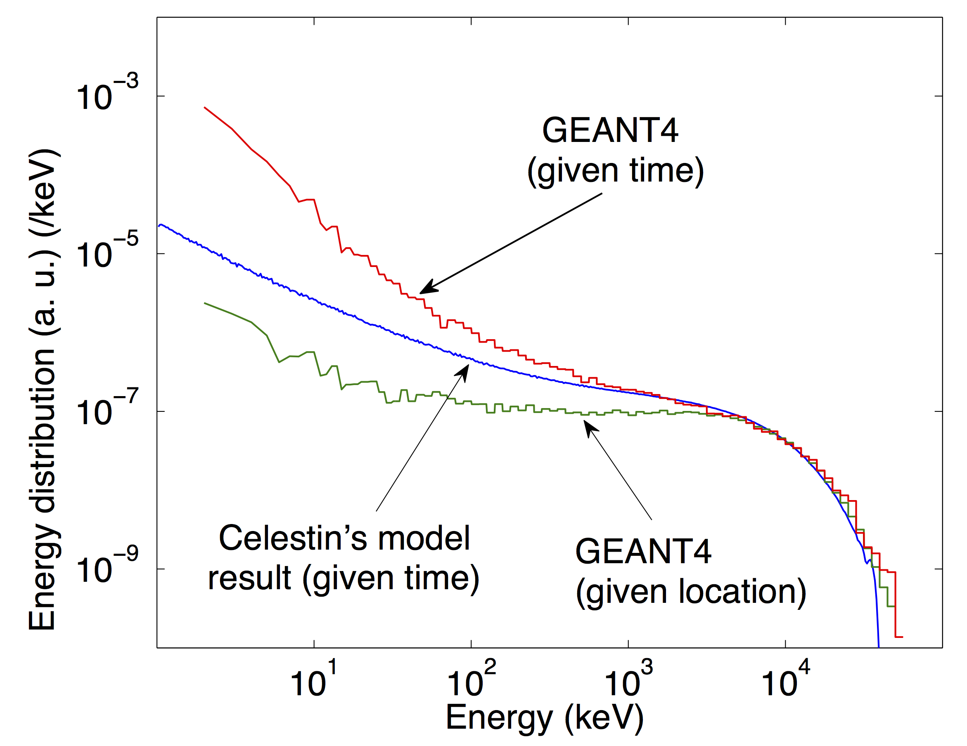Figure 2: The electron energy distrinution obtained from S. Celestin's model (red) and GEANT4 (blue) in an electric field of 18.8 kV/cm.

3) As shown in Figure 2, for a high electric field (18.8 kV/cm), the high-energy cutoff [e.g., see Dwyer et al., 2012] is well captured by both models. For a field of 3.5 kV/cm unexpected discrepancies occurred. Work to understand the cause of these discrepancies is underway.

1. **Future collaboration with host institution (if applicable)**

This short-visit has given us the opportunity to initiate and define an interesting and important project concerning the validation of high-energy atmospheric electricity models used in our community. It also kick-started a collaboration between our groups that will benefit our understanding of TGFs.

Following this preliminary work, much remains to be explored. We are however confident that we are tracking the root causes of the differences in our modeling results.

The next step will be to carefully compare the simulation results obtained in the case of stronger inhomogeneous electric fields. S. Celestin has performed calculations of the inhomogeneous electric field produced by a lightning leader, and the results are ready to be implemented in the GEANT4 model.

We will explore the possibility to adjust the GEANT4 model so that it can provide accurate results for simulations at stronger electric fields.

From the GEANT4 Physics Reference Manual we have also determined some intrinsic differences between the models, which require better understanding before we can determine the effect on the results to come.

1. **Projected publications / articles resulting or to result from the grant *(ESF must be acknowledged in publications resulting from the grantee’s work in relation with the grant)***

We are still in the early stage of the development of the GEANT4-based modeling of TGFs but we intend to wrap this study up in a scientific paper when ready.

1. **Other comments (if any)**

References:

Moss, G. D., V. P. Pasko, N. Liu, and G. Veronis, Monte Carlo model for analy- sis of thermal runaway electrons in streamer tips in transient luminous events and streamer zones of lightning leaders, Journal of Geophysical Research, 111, A02307, 2006.

Dwyer, J. R., Source mechanisms of terrestrial gamma-ray flashes, Journal of Geophysical Research, 113, D10103, 2008.

Celestin, S., and V. P. Pasko, Energy and fluxes of thermal runaway electrons produced by exponential growth of streamers during the stepping of lightning leaders and in transient luminous events, Journal of Geophysical Research, 116, A03315, 2011.

Geant4 collaboration, C., Physics Reference Manual Version 9.6.0, vol. 0, 2012a.

Dwyer, J. R., D. M. Smith, S. A. Cummer, High-Energy Atmospheric Physics: Terrestrial Gamma-Ray Flashes and Related Phenomena, Space Science Reviews, 173, 133, 2012.