**ESF Short Visit Grant**

**FLIM ANALYSIS OF HYBRID STRUCTURES INCORPORATING SEMICONDUCTOR QUANTUM DOTS AND PLASMONIC SUBSTRATES**

**Scientific Report**

**Name of Applicant:** Isabel Moura

**Organization:** Physical Center of Minho University, Braga, Portugal

**Function/Status:** Postdoctoral research fellowship

**Visited Institution:** Materials Physics Center, University of the Basque Country (UPV/EHU), S. Sebastian, Spain

**Contacted Person:** Professor Yury Rakovich

**Introduction**

This report is to fulfill the requirements of the ESF 15 days short visit grant that I received (reference number 6566), covering my time for FLIM studies of hybrid structures incorporating semiconductor quantum dots and plasmonic substrates, at the Materials Physics Center. A copy of the grant application is included in attachment A.

**Purpose of the visit**

The purpose of my short visit to the Materials Physics Center was to perform Fluorescence Lifetime Imaging Microscopy (FLIM) studies of Förster Resonant Energy Transfer (FRET) in self-assembled superstructures consisting of CdTe QDs, on glass coated with either pure polymer or a plasmonic film. Two matrix materials (PS and PVA) and two kinds of plasmonic coatings (TiO2/Au thinfilms and graphene) were analyzed.

This visit also aimed to establish a solid research links between two research groups which can provide interesting possibilities for long-term collaboration.

**Description of the work carried out during the visit**

1. Fluorescence lifetime imaging (FLIM) studies of FRET in self-assembled superstructures consisting of CdTe monosize QDs were performed for two different plasmonic coatings:

* TiO2/Au thinfilms deposited on silicon substrates and annealed at different temperatures (200ºC, 400ºC, 600ºC and 800ºC);
* Graphene prepared by CVD process, deposited on glass substrate.

2. Two polymer matrix materials (PS and PVA) prepared by spin-coating, were used to investigate the FRET enhancement between QDs of two different sizes present simultaneously in the composite film, acting as donors and acceptors, respectively.

**Main results obtained**

**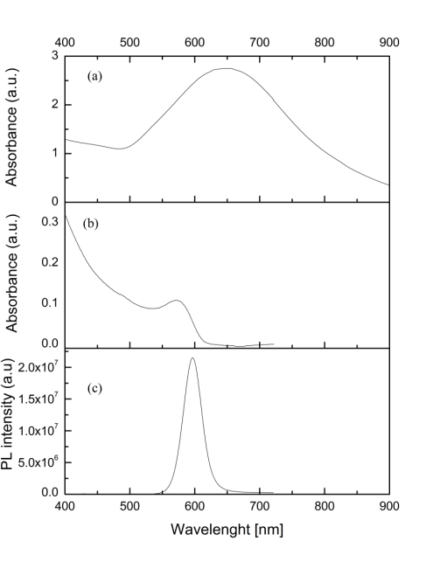**

**Figure 1.** The absorption spectrum of TiO2/Au thin film annealed at 800ºC exhibiting the surface plasmon (SP) resonance at 650 nm (a), CdTe quantum dots absorption (b) and emission (c) spectra in solution.

The absorption spectrum for TiO2/Au thin film annealed at 800ºC is shown in Figure 1, along with the absorption and photoluminescence spectra of CdTe quantum dots (QDs). As it can be seen from these spectra, the TiO2/Au absorption band related to the surface plasmon resonance of free electrons in gold nanoparticles (NPs), overlaps with the CdTe quantum dots (QDs) photoluminescence and absorption spectra. Therefore, one can expect a resonant coupling between excitons confined in QDs and surface plasmons in Au NPs. This could open an additional channel of energy transfer between the dots (QD1→NP→QD2). On the other hand, the QD luminescence can be quenched because surface plasmons are damped and the energy transfer QD→NP may be irreversible, since the energy is dissipated within the metallic particle. Thus, in this work the aim was to investigate the resonance energy transfer by organizing CdTe QDs into self-assembled dendritic structures on plasmonic and non-plasmonic platforms. Previous studies [M. Torrell et al., J. Appl. Phys. 109 (2011), 074310] showed that TiO2/Au thin films produced by sputtering show SPR-related optical response only after annealing at sufficiently high temperatures (above 500ºC).

|  |  |  |
| --- | --- | --- |
| C:\Users\Vera\Desktop\Projeto Física\Results S. Sebastian_2014\SPs AuTiO2_FLIM Analysis\SPs_Wavelenght excitation 485 nm (Final Results)\SPR 5%AuTiO2 (5-16-2014)-Final Results\Sample 1\FAST FLIM Intensity - Sample 1 - Reference.bmp  (a) | (b) | C:\Users\Vera\Desktop\Graph1.jpg  (c) |
| (d) | (e) | (f) |

**Figure 2.** PL intensity (a and d) and PL lifetime (b and e) maps, for pure CdTe QD dendrites fabricated on glass (a and b) and on the surface of a TiO2/Au thin film annealed at 800ºC (d and e), respectively. The corresponding PL lifetime histograms (c and f) were obtained by means of two exponential fitting of the PL decay kinetics at each image spot while scanning over a 82 x 82 m and 67 x 67 m, respectively. The bar heights represent the relative statistical weights of the two components (1, and 2, red). The laser excitation wavelenght is 485 nm.

QD emission was excited by a laser pulse (λexc =485 nm). FLIM images obtained by PL decay mapping of the QD dendritic structures deposited on a conventional substrate and on the surface of a TiO2/Au thin film annealed at 800ºC are presented in Figure 2. According the results of the analysis performed on the PL decay kinetics, it is possible to distinguish two different time scales with characteristic times 1 and 2 (1 > 2). These characteristic times are represented by blue and red colors, respectively, in the histograms of Figure 2. Presumably 1 represents the radiative recombination of a QD exciton (i.e. it is a radiative lifetime characteristic of an isolated QD), while 2 describes energy transfer processes. Figure 2 shows that 2 shortens dramatically for QD dendritic structure on TiO2/Au surface, meaning that the plasmonic substrate leads to the fast PL quenching. The longer characteristic time (1) apparently is also decreased, which means that it is not just the intrinsic radiative lifetime of a single QD and a more complex analysis involving a continuous distribution of lifetimes [C. Bernardo et al., J. Phys. Chem. C 118 (2014) p. 4982 - 90] would be appropriate. We noticed that the decrease of 1 and 2 is observed only for TiO2/Au thin film annealed at 800ºC. According to the FLIM maps, a good homogeneity in the lifetime spatial distribution is observed, even though a slightly higher luminescent core, with a longer 1 is seen for the QD dendrite on the TiO2/Au thin film surface. This observation can be explained by the higher QD density in the core region. Nevertheless, there is no any pronounced inhomogeneity along the structure in the lifetime map, unlike it was found in our recent study of fractal aggregates of CdTe dots [C. Bernardo et al., 2014]. This indicates that the lifetime is almost independent of the local environment in the self-assembled structure and therefore, energy transfer process does not took place within the QD structure but rather to the plasmonic substrate.

|  |  |  |  |  |  |
| --- | --- | --- | --- | --- | --- |
| **Sample** | **Reference** | **TiO2/Au**  **200ºC** | **TiO2/Au**  **400ºC** | **TiO2/Au**  **600ºC** | **TiO2/Au**  **800ºC** |
| **1** | 29.3 | 27.9 | 21.0 | 21.0 | 13 |
| **2** | 12.2 | 12.5 | 5.3 | 7.7 | 0.8 |

**Table 1.** Decay time results (1 and 2) for TiO2/Au samples annealed at different temperatures.

Depending on the morphology, spatial distribution, shape and dimensions of the gold nanoparticles embedded in TiO2, which depend on the annealing temperature, the characteristic PL decay times slightly change (see Table 1). Indeed, the changes are correlated with the onset of the surface plasmon resonance in the nanoparticles and we can conclude that the PL quenching is due to the electromagnetic coupling of the QD excitons to the localised surface plasmons. This is interesting because the dots and the Au NPs are separated by some distance (the former are above the surface and the latter are embedded in the matrix!). It implies that such TiO2/Au can have a potential for environmental sensing applications base on the localized SPR.

In another set of experiments, FLIM studies of FRET in self-assembled superstructures consisting of CdTe QDs were performed, using graphene prepared by chemical vapor deposition (CVD) as a plasmonic coating. Typical PL kinetics are shown in Fig. 3.

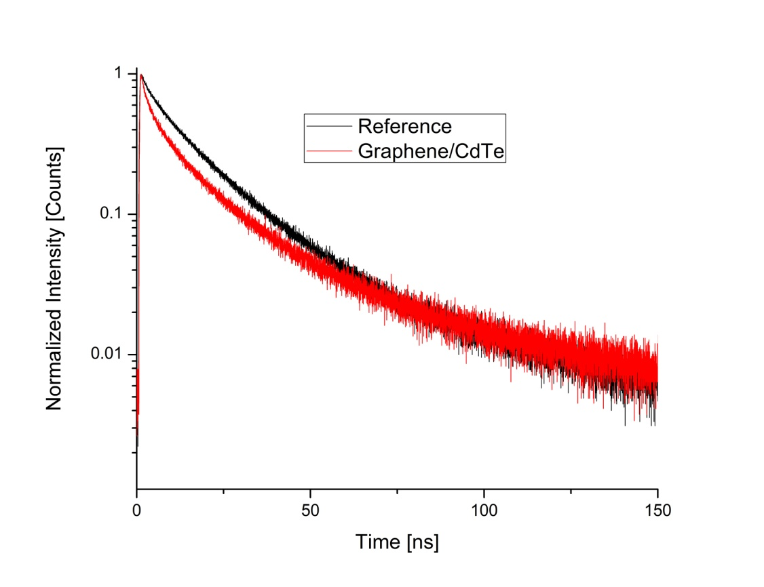

**Figure 3.** Normalized PL intensity kinetics for CdTe QD dendrites fabricated on glass and on graphene-covered glass surface.

The measured average lifetimes for dendritic structures of QDs on conventional substrate are 29.3 ns (1) and 12.2 ns (2), in comparison with average lifetimes of 25.8 ns and 6.9 ns, respectively, for a QD dendrite deposited on graphene surface. Therefore the effect of graphene layer on the characteristic time 1 is rather small but the shorter one (2) seems to be more strongly affected. Further studies are necessary in order to come to solid conclusions.

Finally, FLIM studies of QDs embedded into two different matrix materials (PS and PVA) prepared by spin-coating were performed in order to investigate the possible matrix effect on FRET between QDs of two different sizes acting as donors and acceptors. Water-soluble CdTe-TGA QDs with emission bands centered at 541 nm and 619 nm were incorporated into PVA, and after modification of CdTe-TGA with 1- dodecanethiol (1-DDT), QDs of two different sizes were incorporated in a (water insoluble) PS matrix. In both cases the photoluminescence spectra show two different peaks corresponding to the different QDs sizes (see Fig. 4), although the 1-DDT modification of the dots was found to lead to some changes in the spectral position of the emission peaks (from =541 nm to 532 nm and from 619 nm to 611 nm, respectively).

|  |  |
| --- | --- |
| (a) | (b) |

**Figure 4.** (a) cw-PL spectrum of PVA thin film containing QDs of two different sizes and (b) normalized PL intensity kinetics for donor CdTe QDs (CdTe-TGA 541 nm (D)) and the acceptor CdTe QDs (CdTe-TGA 541 nm/619 nm (DA)).

FRET efficiency, *E*, can be estimated using the relation:

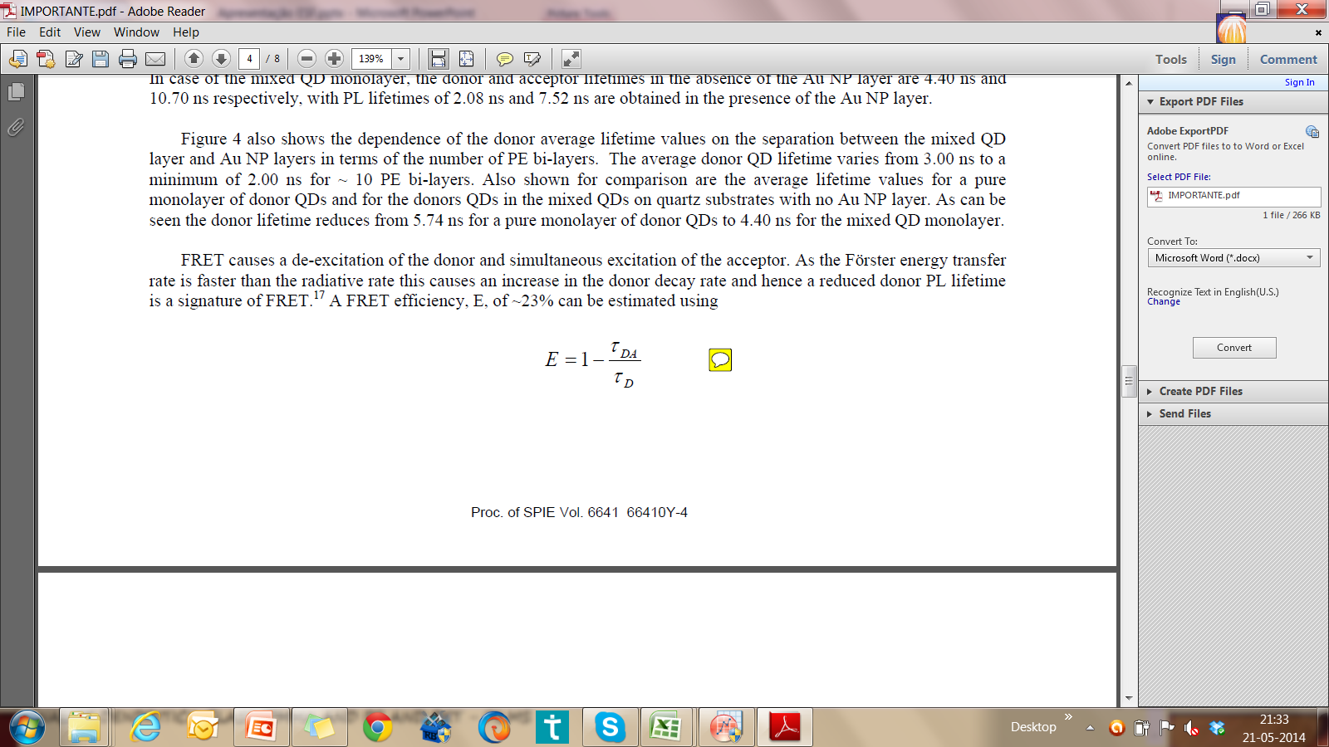

where **D and**DA are, respectively, the average lifetimes of donor QDs alone and in the presence of acceptor dots. It gives the value of 9%. A similar result was obtained for thin films prepared using PS matrix. The low FRET efficiency can be caused by the large distance between the QDs of two different sizes because the QD concentration inside the matrix may have been too low.

**Future collaboration with the host institution**

Other collaboration possibilities are under consideration, in particular, studies of different graphene platforms in terms of their effect on the formation of self-assembled QD structures and inter-dot FRET efficiency.

**Projected publications/articles resulting or to result from the grant**

I will prepare an oral communication using some of the obtained results to present at the 23rd International Conference on Optics in Santiago de Compostela (Spain) in August of 2014.

We are planning to write a joint scientific article on the subject related to FLIM studies of FRET in self-assembled structures consisting of CdTe QDs on TiO2/Au plasmonic substrates.

**Other comments**

This short visit was very useful for me in terms of understanding the capacities and physical background of the FLIM technique. Professionally I benefited a lot from it. Also I believe that this short visit represent a good starting point to future collaboration.

Braga, 27.06.2014

Isabel Moura

University of Minho

Physical Center of Minho University

Campus de Gualtar

4715-057, Braga

Portugal

E-mail: [mouraisabel1@gmail.com](mailto:mouraisabel1@gmail.com)

**Attachment A**

**Short Visit Proposal – Application Form**

***Proposal Title****: FLIM analysis of hybrid structures incorporating semiconductor quantum dots and plasmonic substrates*

**The objectives of the project**

Colloidal semiconductor QDs are very promising candidates to be incorporated into functional devices for sensing and light-harvesting. QD environment has to be taken into account when analyzing energy transfer in QD structures and optimizing them for applications. The interaction of excitons in QDs with surface plasmons (SPs) is expected to enhanced Förster resonant energy transfer (FRET), which has a great potential for energy harvesting and characterization and monitoring processes at metal interfaces. So far, there are only few experimental reports on SPs effects on FRET, particularly for QD systems.

This work foresees fluorescence lifetime microscopy (FLIM) studies of FRET in self-assembled superstructures consisting of CdTe QDs, on glass coated with either pure polymer or a plasmonic film. Two matrix materials (PS and PVA) and two kinds of plasmonic coatings will be analyzed: (i) TiO2/Au thinfilms surface annealed at different temperatures, and (ii) graphene. The goal is to investigate the FRET enhancement between QDs of two different sizes acting as donors and acceptors.