EURAPMON report: Raptor diet as monitoring issue of »monitoring for raptors«: the case study of the Ural Owl in Finland

Author: Stiven Kocijančič (postgraduate student from University of Ljubljana (Slovenia))
Date: 16.7.2013

Purpose of the visit
With this visit I have obtained knowledge for identifying bones and feathers of different animals. Determination of some bones was at the beginning difficult, but with practise I have learned what are main differences between similar bones. The very interesting thing was also to observe amount of prey remains from different nest boxes with relation to number of young chicks. The population dynamics of raptors is usually determined by the fluctuation of their main prey species. The decrease of prey population usually affects raptors by the diet shift with or by lowering their breeding performance. On the other hand it was very intriguing comparing nest boxes from different years, despite I determined only one sample from two years. In general, the Ural Owl is regarded as a vole specialist, but prey availability and small mammal assemblages greatly differ between years. Within short visit I worked and trained on identification of prey remains and its analysis under supervision by Prof. Seppo Sulkava and Prof. Pertti Saurola. Ural Owl’s diet in Slovenia will probably be totally different than here in Finland, so it will be very interesting to conduct comparison between these two well monitored areas.

Introduction
The Ural Owl (Strix uralensis) breeds in Eurasian boreal forests, being a resident and long-lived K-strategist (Korpimäki, 1986). The resident habit has possibly evolved to ensure access to nest-holes, which are in the short supply (Lundberg, 1979). In Fennoscandia voles show 3 to 5 year population cycles, with most pronounced fluctuations in the north (Kalela, 1962) (Hansson in Henttonen, 1985). During cycle Ural Owls experience one or two years which offer good food condition for breeding, and one or two poor years. In order to maximize the number of surviving young produced in a life-time, Ural Owls should adjust their reproductive efforts to fluctuating food condition (Williams, 1966) (Hirschfield in Tinkle, 1975). The Ural Owl is a food generalist, but its diet is only partly explained by opportunistic foraging. However Microtus voles seem to be preferred prey. The year-to-year variation of the diet seemed to be in agreement with the optimal foraging theory in the sense that the diet width tended to increase as the abundance of the preferred prey decreased (Korpimäki in Sulkava, 1987).
The aim of this study was to get insight into diet of Ural owl from different years. In this case we have selected nest boxes from 2009 to 2012. Specially year 2009 is interesting, because the Ural Owls had started with breeding season already at the end of February, which is very early. The reason for this exception probably lies in very warm weather in this part of the year in Finland. This species is distributed in boreal in the Northern as well as in temperate montane forests in Southern Europe. In general, the Ural Owl is regarded as a vole specialist, but prey availability and small mammal assemblages greatly differ between northern and southern regions by voles being dominant in the north and mice on the south.

Methods and material
The results for this study were obtained from analysing material from 12 nest boxes. From every nest, I got one plastic bag (Picture 1) with nest box material, which was picked by Prof. Pertti Saurola. Besides prey remains material contains also branches, bark, dust and larger pieces. Each food sample consisted of pellets and other prey remains collected from a nest-site and from the ground near the nest after the breeding season (mostly in autumn). The samples contain manly the prey items brought by the mates to the nests during the latter part of the nestling period (Lundberg, 1976). Prior, the females removed prey remains from the nests. It is possible that some females cleaned their nests until the end of the nestling period, and in these cases the number of prey items in samples may be low.
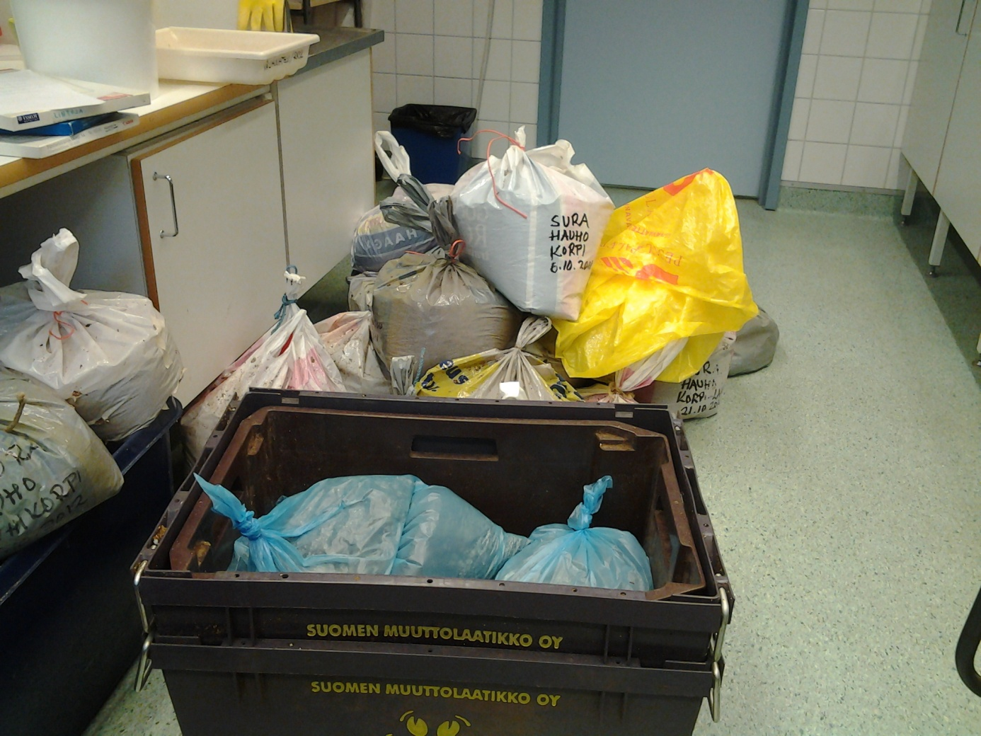
Picture 1: Plastic bags from different nest boxes.
First I had to separate larger pieces from smaller ones. For this I utilized special sieve (Pic. 2), that retained larger pieces, which includes also bones and feather. The samples were dried and later all bones, feathers and scales were separated (Pic. 3).
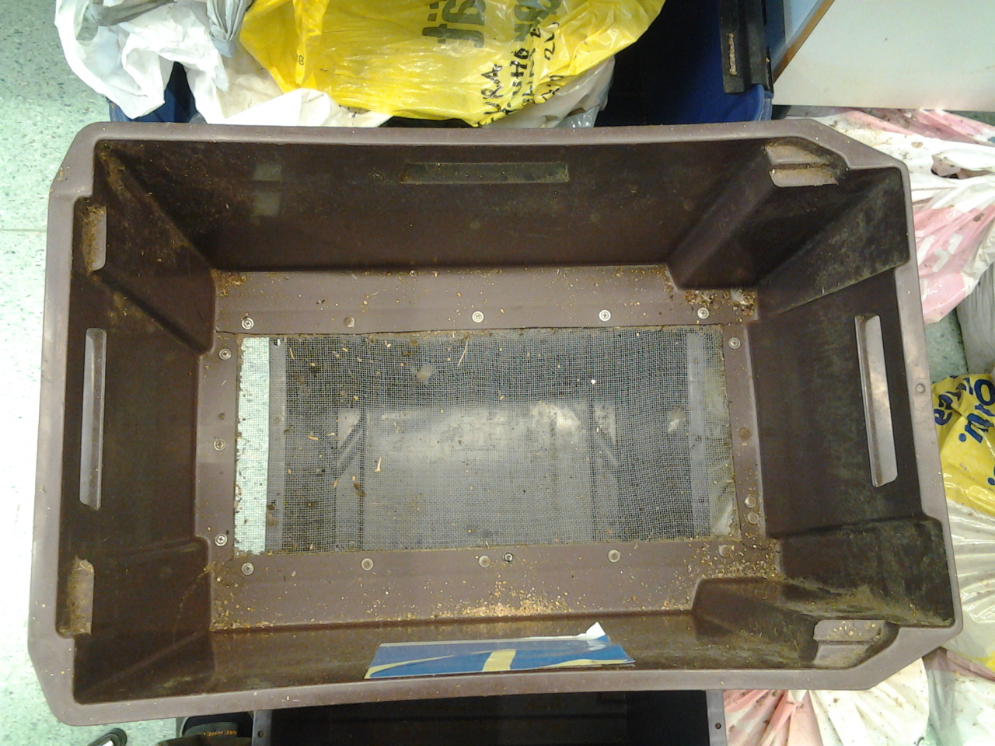
Picture 2: Sieve for separating dust from larger pieces.

The study was carried out in three bigger regions: Hauho, Hattula and Pälkäne in southern Finland. In Hauho region food samples were collected from 2009 to 2012 (a total of 10 samples) in different areas: Hamessuo, Hankalanjärvi, Hyypiö, Joenkylä, Kilintte, Korpilauri, Pyhäniemi, Rihikorpi and Sillänpää. In Hattula region food sample was collected from Korpi area (2012), while in Pälkäne region sample was collected from Kolu area (2009).
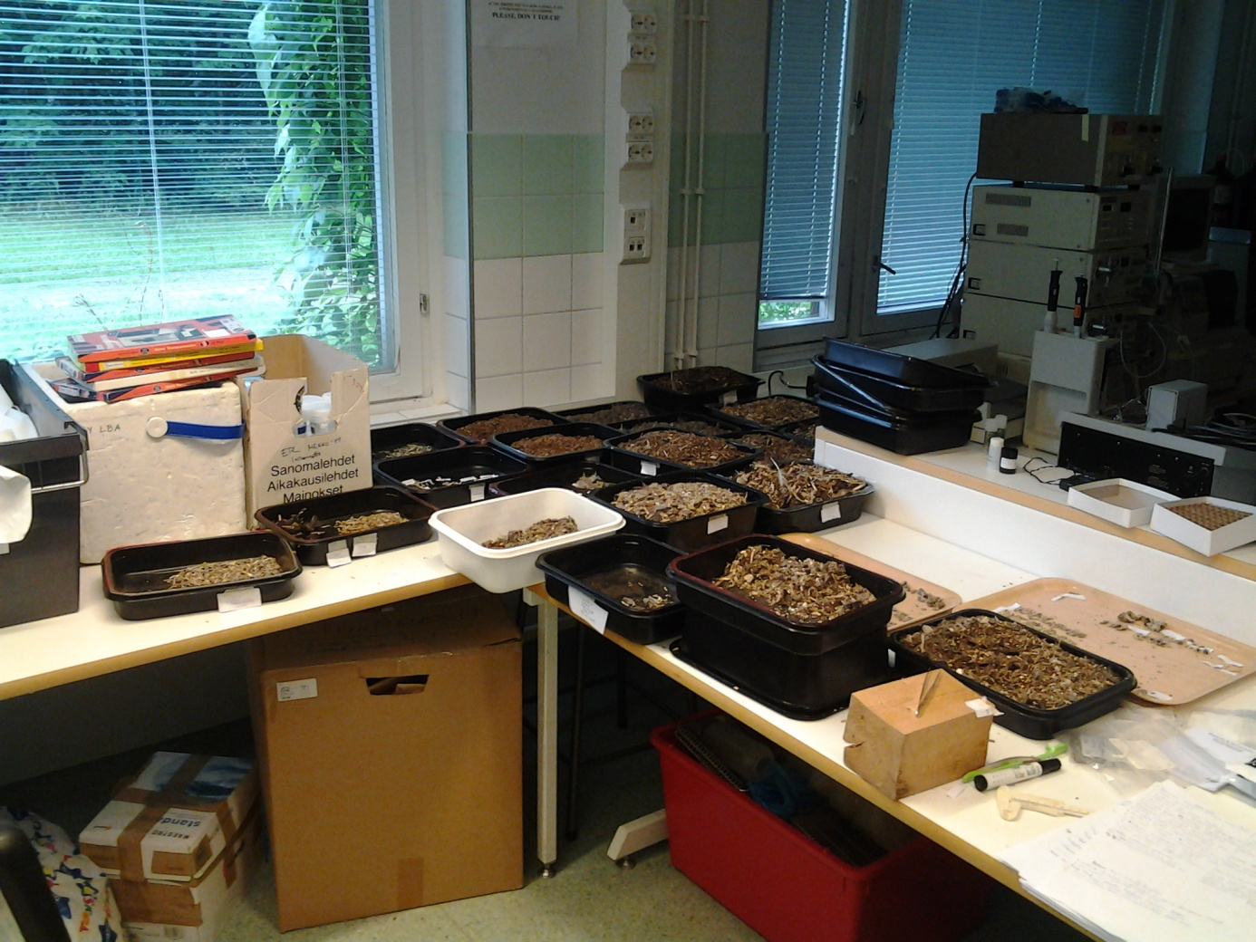
Picture 3: Separated material from different samples.
Prof. Seppo Sulkava helped me with identification of prey remains. He showed me how to separate different species by bones. For this survey we were identifying tibia, femur, coxa, humerus, upper and lower jaws. We have also written down other parts of animals, which had no significant meaning. If possible, also feathers of bird were identified. Small mammal species were determined by comparison with reference material (Pic. 4) from Prof. Seppo Sulkava. The number of individuals was mostly counted on the basis of mandibles, but in few cases the numbers of femurs, tibiae, coxae, humerus of voles, mice, shrews and frogs were larger than those of the mandibles. Not all individuals could be identified to species. The identification of Water Voles (Arvicola amphibious) and larger mammals was mostly based on leg bones and reference material. Separation of the young and adults of the two hare species (Lepus timidus and L. europaeus) was impossible. Birds were identified by comparing humerus or other larger bones, beaks and feathers, with reference material. Frogs and lizards were identified with aid of various major bones, while insects were identified just roughly, because identification of devoured insects was impossible.
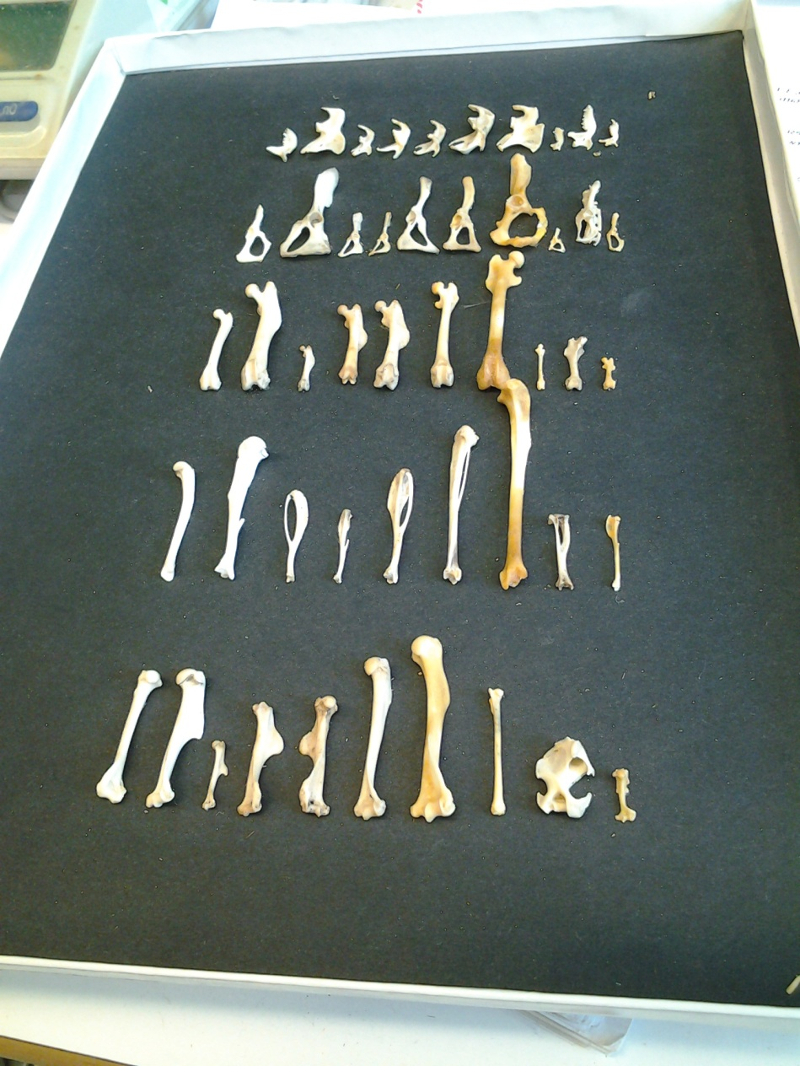
Picture 4: Collection of different bones for identification.
After identification samples were stored into smaller plastic bags (Pic. 5) with proper characterization. For results we were comparing nests from every year, how they differ from area to area. Next to that, we were also investigating differences in diet of Ural Owls from various years from same place.
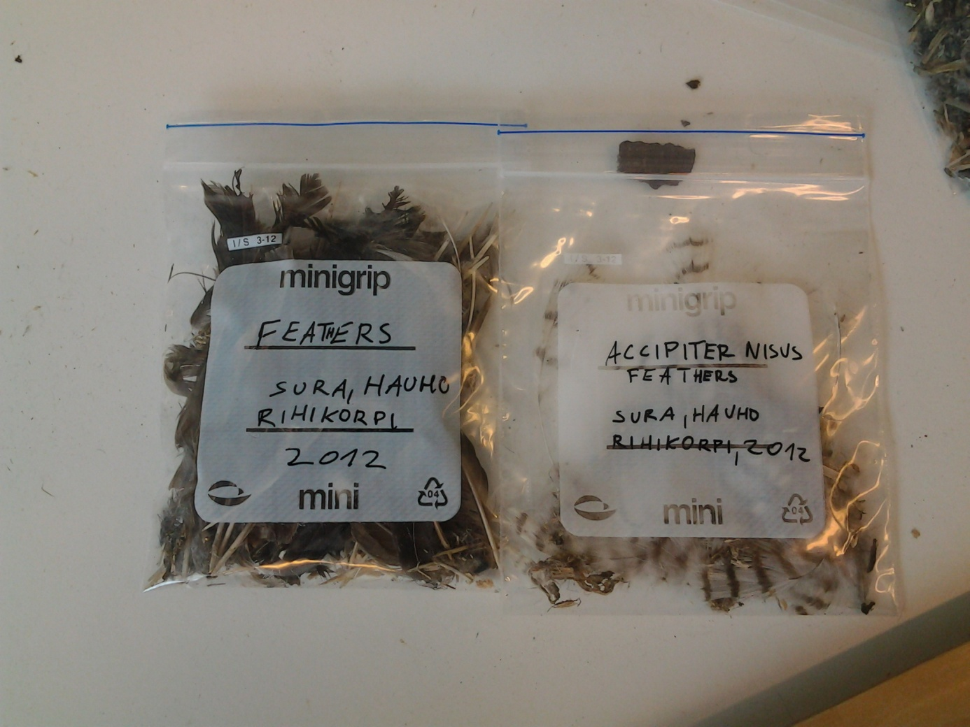
Picture 5: Identified feathers in small plastic bags.

Results
The diet of the Ural Owl comprised mostly mammals, birds and frogs. Among mammals, who also formed the most abundant prey group, the most important prey were Microtus voles by number. The second most frequent preys were Bank Vole (Clethrionomys glareolus) and Water Vole (Arvicola sp.). Other frequent mammals in the diet of Ural Owl were common shrew (Sorex araneus), European mole (Talpa europaea), brown rat (Rattus norwegicus) and young hare (Lepus sp.). Among mammal prey we also found Sicista mouse, Eurasian red squirrel (Sciurus vulgaris), Siberian flying squirrel (Pteromys volans), shrews (Sorex minutus, Sorex caecutiens and Neomys fodiens), yellow-necked mouse (Apodemus flavicollis), house mouse (Mus musculus), Myopus lemming and Least Weasel (Mustella nivalis).
Table 1: Results of the Ural Owl's diet from Hauho, Joenkylä 2009
Species (Laji) | Femur (Reisi) | Tibia (Sääri) | Coxa (Lantio) | Humerus (Olka) | Ulna (Kyynär) | Upper jaw (Yläleuka) | Lower jaw (Alaleuka) | Result
Microtus sp. |  |  |  |  |  | 82 | 111/116 | 116
Clethr. Glareolus |  |  |  |  |  | 4 | 5/6 | 6
Small vole sp. | 107/105 | 103/105 | 63/97 | 81/92 |  |  |  | 0
Arvicola |  | 2/1 |  |  |  |  |  | 2
Apodemus flavic. | 3/5 | 2/0 | 0/2 | 2/2 |  |  |  | 5
Sorex araneus |  | 1 |  |  |  |  |  | 1
Talpa eur. | 1/1 | 1/1 | 1 | 1 |  |  |  | 1
Rattus nor. juv. |  | 1/1 |  | 1 |  |  |  | 1
Turdus sp. ad. |  |  |  | 1 |  |  |  | 1
Turdus sp. juv. | 1 | 2 |  |  |  |  |  | 1
Phylloscopus- size | 1 |  |  | 2/1 |  | 1 | 3 | 3
Regulus |  | 0/2 |  |  |  |  |  | 2
Material, total |  |  |  |  |  |  |  | 139

Birds were second most abundant prey group. The most frequent preys by number were adults and juveniles of thrushes (Turdus sp.), followed by birds of Fringilla, Great tit and Phylloscopus size. Almost in every sample we found Eurasian woodcock (Scolopax rusticola). Bird prey also included hazel grouse (Tetrastes bonasia), wood pigeon (Columba palumbus), sparrowhawk (Accipiter nisus), Tengmalm's owl (Aegolius funereus), jackdaw (Corvus monedula) and Eurasian jay (Garullus glandarius). The diet compositions between regions were slightly different.
Table 2: Results of the Ural Owl's diet from Hauho, Korpilauri 2010.
Species (Laji) | Femur (Reisi) | Tibia (Sääri) | Coxa (Lantio) | Humerus (Olka) | Ulna (Kyynär) | Upper jaw (Yläleuka) | Lower jaw (Alaleuka) | Result
Microtus sp. |  |  |  |  |  | 9 | 10/9 | 10
Clethr. Glareolus |  |  |  |  |  | 14 | 13/13 | 14
Small vole sp. | 15/15 | 19/25 | 13/11 | 12/11 |  |  |  | 1
Arvicola |  |  |  | 1 |  |  |  | 1
Rattus norw. | 3/2 | 1/1 | 2/2 | 1/1 | 2 |  |  | 3
Mus musculus | 1 |  |  |  |  |  |  | 1
Apodemus flavic. | 1/1 | 4/2 | 2/1 |  |  |  |  | 4
Sicista |  | 1 | 2/3 | 1 |  |  | 4/3 | 4
Sorex araneus | 8/1 | 9/5 | 13/8 | 10/8 |  | 9 | 14/17 | 17
Sorex caecutiens | 3/5 |  | 3/1 |  |  |  | 2/1 | 5
Lepus sp. |  | 5 | 2 |  |  |  |  | 3
Lepus sp. juv. |  | 2 | 2 |  |  |  |  | 1
Turdus sp. ad. | 4 | 11/15 |  | 1/3 |  |  | 2 | 8
Turdus sp. juv. |  | 2/0 |  | 1 |  |  |  | 1
Great tit- size |  | 0/2 |  | 2/1 |  |  |  | 2
Tetrastes bonasia |  |  |  | 1 | 1 |  |  | 1
Very small bird sp. | 1 |  |  | 1 |  |  |  | 1
Material, total |  |  |  |  |  |  |  | 77

Frogs (Rana temporaria and Rana arvalis) were also regularly occurring in the samples from nest boxes. Among prey remains we also found some large beetles (Carabus sp. and Geotrupes sp.), wasps and bumblebee (Bombus sp.).

Table 3: Results of the Ural Owl's diet from Hauho, Joenkylä 2011.
Species (Laji) | Femur (Reisi) | Tibia (Sääri) | Coxa (Lantio) | Humerus (Olka) | Ulna (Kyynär) | Upper jaw (Yläleuka) | Lower jaw (Alaleuka) | Result
Microtus sp. |  |  |  |  |  | 8 | 9/7 | 9
Clethr. Glareolus |  |  |  |  |  | 1 | 7/5 | 7
Small vole sp. | 18/13 | 11/12 | 8/9 | 10/15 |  | 6 | 10/9 | 2
Mus musculus | 2/2 |  |  |  |  |  |  | 2
Sorex araneus | 1/0 | 1/1 |  |  |  |  | 1 | 1
Bombus sp.
Turdus sp. ad. | 8 | 7/23 |  | 3/6 |  |  | 4 | 12
Turdus sp. juv. | 5 | 5/12 |  | 1 | 2 |  |  | 6
Fringilla- size | 1 | 2/1 |  | 2/1 |  |  | 1 | 2
Aegolius funereus | 2/1 | 2/3 |  | 1/2 |  | 1 |  | 2
Columba palumbus |  | 0/1 | 1 | 0/1 | 2 |  |  | 1
Material, total |  |  |  |  |  |  |  | 44

Yearly variations
If we compare different areas, we can see that proportion of Microtus voles in the diet varied widely (Tables 1, 2, 3 and 4). Increased proportion of Microtus is noticed in year 2009 (Tab. 1), while in years 2010, 2011 and 2012 proportions were lower. In these years increased proportion of passerine birds and also others (owls, pigeons, hawks...) The proportion of frogs, shrews and birds seemed to fluctuate inversely with the proportion of Microtus voles in the diet.
Table 4: Results of the Ural Owl's diet from Hauho, Korpi 2012.
Species (Laji) | Femur (Reisi) | Tibia (Sääri) | Coxa (Lantio) | Humerus (Olka) | Ulna (Kyynär) | Upper jaw (Yläleuka) | Lower jaw (Alaleuka) | Result
Clethr. Glareolus |  |  |  |  |  |  | 2/0 | 2
Small vole sp. | 1/0 | 2/0 | 1/1 | 1 |  |  |  | 0
Arvicola | 1 | 1 |  |  |  |  |  | 1
Apodemus flavic. | 1 |  |  |  |  |  |  | 1
Sicista |  |  |  |  |  |  | 1 | 1
Sorex araneus | 1/1 | 1 | 2/0 |  |  |  | 1/1 | 2
Lepus sp. juv. |  |  | 1 |  |  |  |  | 1
Rana sp. |  | 2 |  |  |  |  |  | 2
Large beetle sp |  |  |  |  |  |  |  | 1
Bombus sp.
Turdus sp. ad. |  |  |  | 1 |  |  |  | 1
Turdus sp. juv. |  | 1/2 |  |  |  |  |  | 2
Great tit- size | 1 | 1/2 |  |  |  |  |  | 1
Scolopax |  | 1/1 |  |  | 1 |  |  | 1
Material, total |  |  |  |  |  |  |  | 16

Future collaboration with host institution
In the future I would like to work with other birds of prey and owls. I'm interested in the diet of Tawny owl (Strix uralensis), Eagle owl (Bubo bubo) and osprey (Pandion haliaetus), hence Finland seems proper country for comparison with Slovenia, despite the fact we can see osprey in our country just on migration.

Literature
Hansson L. And Henttonen H. 1985. Gradients in density variations of small rodents: the importance of latitude and snow cover. Oecologia (Berlin) 67: 394-402.
Hirshfield M.F. and Tinckle D.W. 1975. Natural selection and evolutions of reproductive effort. Proc. Nat. Acad. Sci. USA 72 72: 2227-2231.
Kalela O. 1962. On the fluctuations in the numbers of arctic and boreal small rodents as a problem of productions biology. Ann. Acad. Sci. Fennicac. A IV 66:1-38.
Korpimäki E. 1986. Niche relationships and life-history tactics of three sympatric Strix owl species in Finland. Ornis Scand. 17: 126-132.
Korpimäki E. and Sulkava S. 1987: Diet and breeding performance of Ural Owls Strix Uralensis under fluctuating food conditions. Ornis Fennica 64: 57-66.
Lundberg A. 1976. Breeding success and prey availability in a Ural Owl Strix uralensis Pall. Population in Central Sweden. Zoon 4: 65-72.
Lundberg A. 1980. Residency, migration and a compromise: adaptations to the nest-site scarcity and food specializations in three Fennoscandian owl species. Oecologia (Berlin) 41: 273-281.
Williams G.C. 1966. Natural selections, the costs of reproductions and refinement of Lack's principle. Am. Nat. 100: 687-690.

