Scientific Report for Short Visit Grant
Dr. Roberto Benocci

SUBJECT: Super-intense laser-matter interactions SILMI / PESC
Proposal Title “Set-up of an X-ray diagnostic for Kα measurements”
Application Reference N°: 6530

FACILITY: CELIA, Université Bordeaux 1, Bordeaux , France.
From March 10th to March 21th 2014.
Invited by
J. J. Santos, Associate Professor
Université Bordeaux 1, (Centre Lasers Intenses et Applications)
351, Cours de la Liberation
33405 Talence cedex, France
e-mail: joao-jorge.santos@u-bordeaux1.fr

Purpose of the visit:
setting-up an x-ray diagnostic to characterize the fast electron generation and transport mechanisms relevant for the fast ignition (FI) and shock ignition (SI) scheme. During the visit such x-ray diagnostic set-up has been useful to start a characterization of quartz crystals’ reflectivity to obtain realistic information of the photon flux and energy spectrum. This activity was also introductory to the upcoming experiment at PALS, Prague, on the “study of hot electron production and shock generation in SI-relevant regime”.

Introduction
The study of fast electron transport in matter is of critical importance for the development of both fast ignition and shock ignition schemes. In the fast ignition approach to inertial confinement fusion, the compression and ignition stages are separated. The compressed deuterium-tritium fuel is expected to be heated by a fast electron beam, generated by a ultra-intense laser pulse that releases its energy in the compressed core. The typical parameters of the fast electron beam are 10 kJ of energy and 10 ps duration with average electron energy of the order of 1 MeV.
In this context a characterization of the fast electron beam is highly desirable in order to understand the underlying physics and evaluate the feasibility of this scheme.
Also in the SI scheme the compression phase is separated from the ignition phase. The target compression is induced by laser irradiation at intensities below 10¹⁵ W/cm² similar to the conventional direct-drive scheme, but at a slower implosion velocity. At a few hundred ps before maximum compression the target is then irradiated by a 300-500 ps duration laser pulse at higher intensity (10¹⁶ W/cm²) to generate a converging shock wave with a pressure of the order of 300 Mbar. The shock wave is further amplified by the geometrical convergence, capable of rising the plasma temperature and density to the ignition conditions for fusion in a hot spot. The major advantage of this scheme is the fact that it is less subject to the detrimental effects of the Rayleigh-Taylor instability, since it requires a slower implosion velocity than the conventional scheme.
Supra-thermal electrons are traditionally considered to be dangerous in ICF since they could preheat the assembled fuel leading to a premature expansion. On the other hand, in SI, they may turn out to be a positive factor provided they have energies below 100 keV and are hence unable to penetrate through the target to the dense core. Indeed being stopped in the outer shell, they could enhance the shock drive performance which otherwise could be negatively affected by the presence of an extended plasma corona when the final laser spike is launched (delocalized absorption).
A fast electron beam propagating through a medium, releases its energy in several ways: interacting with bound and free electrons, exciting plasma waves, and radiating via bremmstrahlung emission. Of particular interest is the interaction with bound electrons that may result in the collisional ionization of the atoms composing the target material. The K-shell is the inner atomic shell and its electrons have the highest binding energy. K-shell ionization may be followed by the emission of a Kα photon. This has a maximum for E ≈ 3Ek, where Ek is the ionization energy, and it then decreases at higher energies, reaching a minimum corresponding to E ≈ 1 MeV. Notice that this is just the average energy required in the fast ignition scheme. Therefore the maximum probability to produce Kα radiation corresponds to relatively low fast electron energy, being 30-40 keV for Cu (ionization potential 8979 eV [1]). Typically, Kα diagnostics are either spectroscopic or imaging, both being based on Bragg’s law for reflection, using crystals in spectroscopic and imaging configuration.

Spherically bent crystal for imaging

A spherically bent crystal can be used to obtain 2-D spatially resolved images of the Kα source [2]. The diagnostic is based on the famous Bragg’s law for reflection:

$$nλ=2dsinθ_{B}$$

where d is the inter-planar distance for the crystal planes parallel to the surface. In the most simple formulation of x-ray diffraction, a given crystal surface will reflect only monochromatic radiation incident at the Bragg’s angle${ θ}_{B}$. However, when we take into account the presence of defects and stacking faults in the crystal structure, considering multiple scattering and absorption, we see that for a given incidence angle the crystal can scatter a narrow, but not monochromatic, range of wavelengths. Furthermore, in the case of a bent crystal, each point on the crystal surface will see the incoming radiation at a different incidence angle.
To ensure a high quality imaging the Bragg’s angle must be close to 90°; in this condition the point source and the image are simply related by the spherical mirror equation (see Figure 1):

$$\frac{1}{p}+\frac{1}{q}=\frac{2}{R}$$

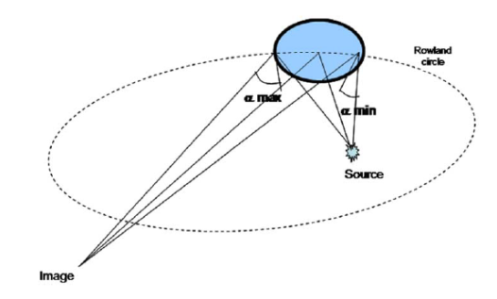
Figure 1: Schematic of the spherically bent crystal in imaging configuration.

The constraint on large Bragg angle reduces the number of crystals suitable for high resolution imaging; the most used crystals are the Quartz 21-31, 2d spacing: 3.082 Å , for which Bragg angle for Cu Kα radiation at 8.047 keV is θ_{B} =88.631 and the quartz 203, for Ti Kα. The quartz 21-31 for Cu is the most widely used because of the relatively high ionization potential of the Cu K-shell (8979 eV) that allows the radiation produced by higher energy electrons to be imaged. In our case, we consider a spherically bent alpha quartz crystal, with a radius of curvature R = 38cm and a diameter of 2.5 cm.
From the image it is possible to get information about the width of the electron beam and the total flux of K_{α} photons, and finally to retrieve the flux and energy of the hot electron population.
However, to be used in such a spectrometer, a crystal needs a high quality surface, and its reflective properties have to be accurately calibrated: without a good knowledge of the crystal reflectivity it would be impossible to retrieve the total x-ray flux from the measured signal.
In an ideal case, the crystal should be able to reflect only a precise wavelength according the Bragg's law, nevertheless, due to defects, internal strains, etc..., any real crystal can reflect a narrow band of frequencies. The curve which describes the reflectivity dependence of a crystal is called rocking curve and can be calculated from theoretical models and computational methods.
A real rocking curve, especially for a bent crystal, can vary a lot with respect to the theoretical one and direct measurements are necessary for an accurate calibration.
For this reason an experimental apparatus was set-up to measure the Kα radiation reflected by different crystals and comparing the flux on the crystal with a calibrated detector. The measurements were taken at the facility ECLIPSE in CELIA (University of Bordeaux 1). We used as a source the Kα radiation of copper.

Diagnostic set-up and measurements
The experience was realized using the Laser ECLIPSE of the CELIA, whose characteristics are the following: intensity on the target about 10¹⁸ W/cm², wavelength 800 nm, duration 50 fs, contrast 10⁻⁶, rms stability 14.0-1.5 % and incident angle 33°. The laser was used to create a fast electrons' beam inside the target of 10 µm of copper which interacts with the background electrons of the target creating an x-ray emission as Bremsstrahlung or Kα emission. To obtain the imaging of Kα radiation and measure the reflectivity of the crystal we used two configurations. In the first one the Spherical Crystal is used as an Imager (SCI) and in the second for calibrating the two CCD used in the first configuration.
In the SCI configuration (Figure 1a), the crystal is used as an imager. This means that an image of the back of the target will be focused on a CCD. The good position of the crystal is selected with the Bragg's law and the conjugation relation. With these information, we can set the proper position of the crystal and the Andor CCD (distance target-crystal p = 225mm and distance crystal-CCD Andor q = 1215mm). The position of the camera corresponds to a magnification of 5.4. Therefore, for each series of shots, we can obtain an image of the reflected Kα x-ray by the crystal. Another CCD Princetone is used as a reference as shown in figure 1b. This CCD is used in single photon counting mode. This means that the distance between two photons on the CCD is greater than three pixels. With this condition, we are sure that the intensity in each pixel corresponds to the energy of each photon. This is called MatriX configuration. The analysis of the CCD allows to obtain a spectrum of the emission of the x-ray by the target. The main problem here is that the Princetone CCD is not calibrated and therefore we do not know the equivalence between intensity in each pixel/ energy of the photon. The calibration configuration used the Princeton and the Andor Camera in single photon counting. In this case we just moved the Andor CCD in order to have the same observation's angle of the crystal in the SCI configuration.

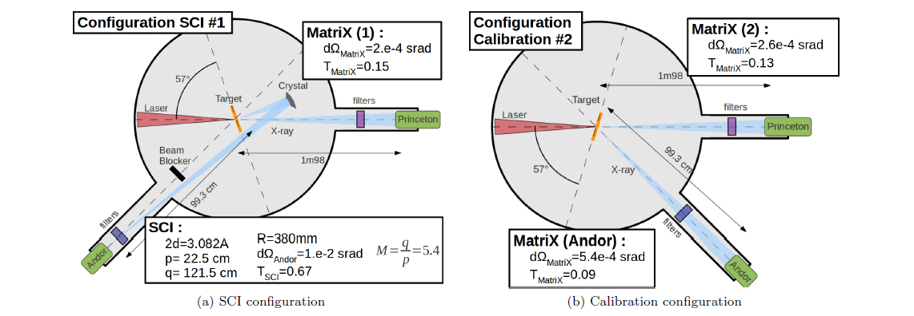
Figure 2: Two configurations used to characterize the reflectivity of the crystal; (a) Spherical Crystal Imaging (SCI) configuration; (b) Calibration configuration.

The spherical crystal makes an image of the Kα emission of the copper target as shown in figure 3. This spot can be fit by a Gaussian of equation: a₀·exp(-(r-r₀)²)+b₀ with a₀ the maximum intensity (CCD counts), r₀ the position of the middle of the Gaussian, $2\sqrt{2ln2}σ$ the Full Width at Half Maximum (FWHM) and b₀ the background noise.
The integration of this Gaussian (without the background) provides the total number of photon reflected by the crystal:
I_{SCI} = N_{ph} $\frac{dΩ_{SCI}}{4π}R_{cry}{CCD}_{eff Andor}T_{SCI}$
with I_{SCI} the number of charges received by the Andor CCD, N_{ph} the number of photons emitted by the copper target, $\frac{dΩSCI}{4π}$ is the solid angle of the SCI diagnostic, R_{cry} is the reflectivity of the crystal, CCD_{eff Andor} is a factor corresponding of the total CCD efficiency of the Andor camera (Quantum efficiency and conversion factor between eV to CCD counts) and T_{SCI} is the filters' transmission in front of the Andor CCD.
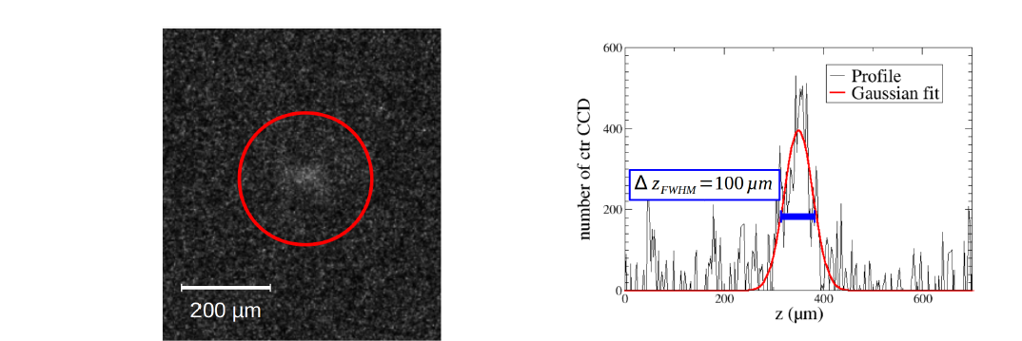

Figure 3: Typical image reflected by the spherical crystal. | Figure 4: Longitudinal profile of the spherical crystal image.

From the data of single photon counting (calibration configuration) and the matching of the photon energy to the pixel energy [3], it will be possible to retrieve the photon spectrum with the number of photons emitted by the source and therefore obtain the reflectivity of each crystal.

Future collaboration with host institution
Our common interests have already led to the realization of different experiments realized by the Prof D. Batani' s Bordeaux group. In particular, the upcoming experiment at PALS (Prague) will benefit of the experience I made during my visit in Bordeaux. Our future collaboration will be addressed to make studies on both inertial confinement fusion in the "Fast Ignition" (FI) and “Shock Ignition” (SI) approach and to continue the ongoing research on highly compressed materials.

Projected pubblications/articles
We expect to submit a paper on the results of these measurements by the second half of 2014 as well as from the results of the upcoming experiment on SI at PALS which will benefit of the experience made on the setting-up of the Kα imaging diagnostic.

References
[1] X ray Data Booklet now available. Journal of Synchrotron Radiation, 8(4):1125-1125, 2001.

[2] J. Koch, et al., Rev. Sci. Instrum. 74 (2003) 2130.

[3] C. Fourment, N. Arazam, C. Bonte, T. Caillaud, D. Descamps, F. Dorchies, M. Harmand, S. Hulin, S. Petit and J.J. Santos. Broadband, high dynamics and high resolution charge coupled device-based spectrometer in dynamic mode for multi-keV repetitive x-ray sources. Rev. Sci. Instrum., 80(083505), 2009.

