Visit Summary – Grant 4963
Prof. Yoav Yair, Interdisciplinary Center (IDC) Herzliya, Israel
Visit to DTU/Space – Lingby, Copenhagen, 28 June – 10 July 2015
The purpose of my visit to DTU/Space was to establish and practice the operational procedures for the THOR experiment, that is planned to be performed on-board the International Space Station by Denmark's ESA astronaut Andreas Mogensen during his SDM (short-duration mission) scheduled for September 2-12th, 2015.
The THOR experiment will study several atmospheric phenomena that occur above thunderstorms, such as transient luminous events (TLEs), gravity ways and the penetration of convective turrets into the lower stratosphere. The basic requirement is to image these phenomena using a Nikon D4 camera that is on-board the ISS, through the windows of the Russian PIRS module.
The purpose of my visit was to develop a prediction methodology of the times and locations of global deep convection and lightning activity. This procedure was then rehearsed and practiced for several days, with very good results.
My hosts were Prof. Torsten Neubert and Dr. Olivier Chanrion. We worked very closely in establishing the information flow, and the content of the messages to be uplinked to the ISS. This was done on a daily basis, based on the atmospheric models and forecasting procedures I developed for the MEIDEX that was performed on board the space shuttle Columbia in 2003 (e.g. Ziv et al., 2004 and Yair et al., 2004). We produced daily target list (Appendix 1a) and based on the ISS orbital predictions (Appendix 1b) were able to select and prioritize the targets to be imaged by the astronaut. Further to this list, O. Chanrion had developed a special software tool that enables the derivation of specific instructions for the observations, which included azimuth and elevation angles from the window and the manner in which the target will appear in the Field-of-View (Appendix 2).
This information was compiled into an operational message that was relayed to B-USOC (Belgian User Support and Operations Center; http://www.busoc.be/). The selected (prioritized) targets were then incorporated into the daily execute package that is relayed through mission control to the astronaut in orbit. The procedure will be rehearsed again in a "dry-run" that is planned for the week of July 27th.
My continued collaboration with DTU/Space will be manifested during the actual experiment, when THOR will be launched on September 2nd. A second visit is planned to DTU from September 2nd-10th.
We plan to evaluate the outcome of our prediction scheme and its accuracy in forecasting global deep convection and lightning activity, in a similar manner conducted on the targets selected for observations from the ISS during 2011 JAXA "Cosmic Shore" campaign, as published in Yair et al. (2013). This will likely result in a publication with my co-authors Neubert and Chanrion. Of course, if successful observation as achieved and images of sufficient quality are obtained during this experiment, this will produce additional publications.

References
Ziv, B., Y. Yair, K. Pressman and M. Fullekrug, 2004: Verification of the Aviation Center global forecasts of Mesoscale Convective Systems. Jour. App. Meteor., 43, 720-726
Yair, Y., P. Israelevich, A. Devir, M. Moalem, C. Price, J. Joseph, Z. Levin, B. Ziv and A. Teller, 2004: New sprites observations from the space shuttle. J. Geophys. Res., 109, D15.
Yair, Y., C. Price, D. Katzenelson, N. Rosenthal, L. Rubanenko, Y. Ben-Ami and E. Arnone (2014), Sprite Climatology in the Eastern Mediterranean Region. Atmos. Res., doi.10.1016/j.atmosres.2014.12.018

Appendix 1a – Target list
Target Locations list for July 7th 2015 – July 8th 2015
Target Type | July 7th 0600 UT | July 7th 1200 UT | July 7th 1800 UT | July 8th 0600 UT | July 8^{h} 1200 UT | July 8th 1800 UT | Comments  TS=Tropical Storm  Typh=Typhoon
Turrets 1 -Daytime | 20.6400 119.7240 |  |  | 22.5330, 121.0470 |  |  | TS Linfa  (near Taiwan)
Sprites 1 -nighttime |  |  | 21.1970 120.125 |  |  | 23.7600 119.284 | TS Linfa  (near Taiwan)
Turrets 2 -Daytime | 17.8110 136.9640 |  |  | 19.4300 132.8550 |  |  | TS 09W Chan-Hom
Sprites 2 -nighttime |  |  | 18.4380 134.7200 |  |  | 20.6230 130.902 | TS 09W Chan-Hom
Turrets 3 -Daytime | 12.8730 154.8140 |  |  | 15.3580, 151.1060, |  |  | TS Nangka  Cat 1 typh.
Sprites 3 -nighttime |  |  | 13.7790 153.0780 |  |  | 16.5100 149.3700 | TS Nangka  Cat 1 typh.
Turrets 4 - daytime |  |  | 7.0570  -89.4510 |  |  | 6.4300  -88.9560 | West of Costa-Rica

Appendix 1b – ISS orbits
Sprite observation windows for ISS, 7/7/2015
Orbits at 06:00Z

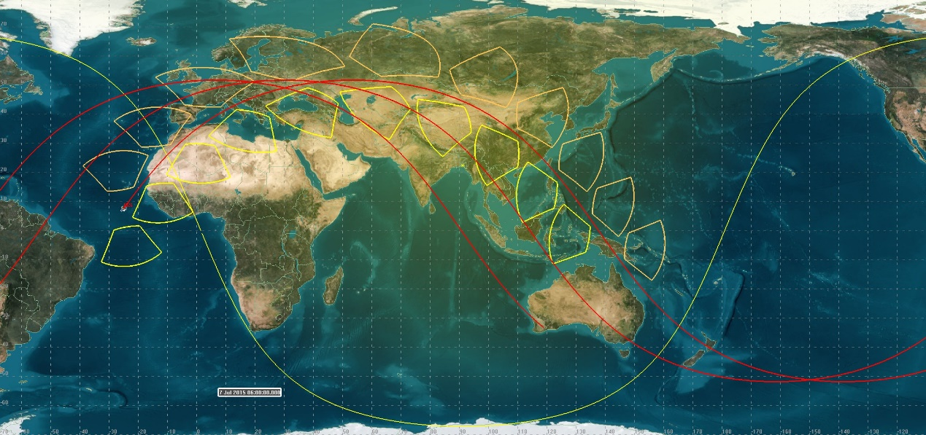
Time (UTCG) Detic.LLA.Latitude (deg) Detic.LLA.Longitude (deg)
------------------------ ------------------------ -------------------------
Orbit 1, day orbit:
7 Jul 2015 06:00:00.000 7.679 -24.976
7 Jul 2015 06:05:00.000 22.629 -13.189
7 Jul 2015 06:10:00.000 36.254 1.636
7 Jul 2015 06:15:00.000 46.886 22.309
7 Jul 2015 06:20:00.000 51.743 50.118
7 Jul 2015 06:25:00.000 48.683 79.054
7 Jul 2015 06:30:00.000 39.135 101.498
7 Jul 2015 06:35:00.000 26.019 117.450
7 Jul 2015 06:40:00.000 11.267 129.749
7 Jul 2015 06:45:00.000 -4.046 140.687
7 Jul 2015 06:50:00.000 -19.151 152.084
7 Jul 2015 06:55:00.000 -33.182 165.924

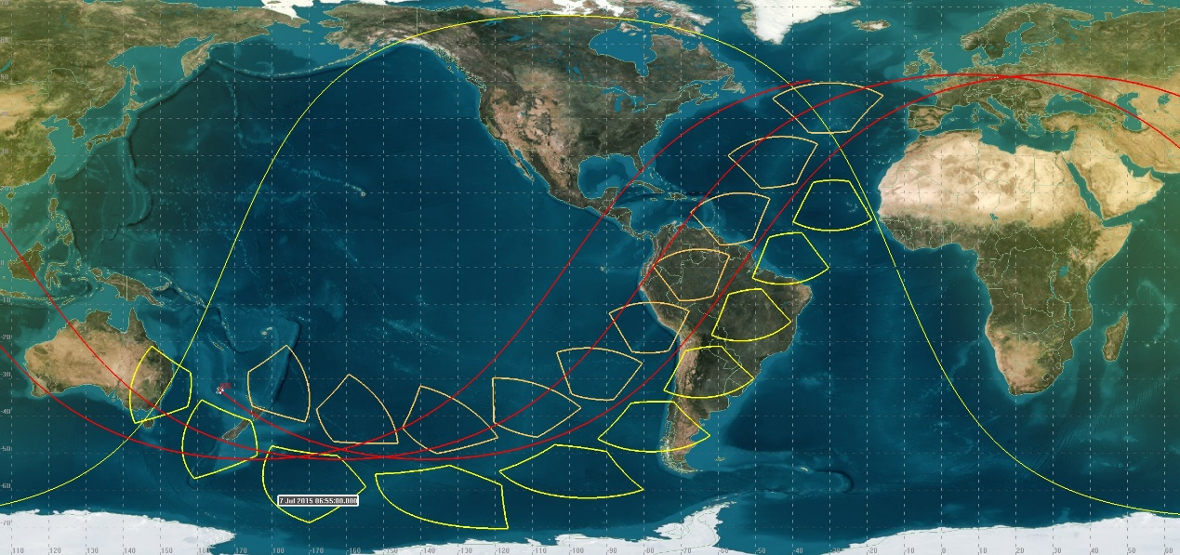
Time (UTCG) Detic.LLA.Latitude (deg) Detic.LLA.Longitude (deg)
------------------------ ------------------------ -------------------------
Orbit 2: night
7 Jul 2015 06:55:00.000 -33.182 165.924
7 Jul 2015 07:00:00.000 -44.715 -175.137
7 Jul 2015 07:05:00.000 -51.247 -148.974
7 Jul 2015 07:10:00.000 -50.176 -119.529
7 Jul 2015 07:15:00.000 -42.019 -95.280
7 Jul 2015 07:20:00.000 -29.637 -77.994
7 Jul 2015 07:25:00.000 -15.228 -65.038
7 Jul 2015 07:30:00.000 -0.010 -53.948
7 Jul 2015 07:35:00.000 15.221 -42.848
Orbit 3:
7 Jul 2015 08:25:00.000 -26.343 135.013
7 Jul 2015 08:30:00.000 -39.367 151.020
7 Jul 2015 08:35:00.000 -48.789 173.503
7 Jul 2015 08:40:00.000 -51.730 -157.641
7 Jul 2015 08:45:00.000 -46.827 -130.008
7 Jul 2015 08:50:00.000 -36.213 -109.456
7 Jul 2015 08:55:00.000 -22.622 -94.685
7 Jul 2015 09:00:00.000 -7.695 -82.917
7 Jul 2015 09:05:00.000 7.621 -72.041

Orbits at 12:00Z
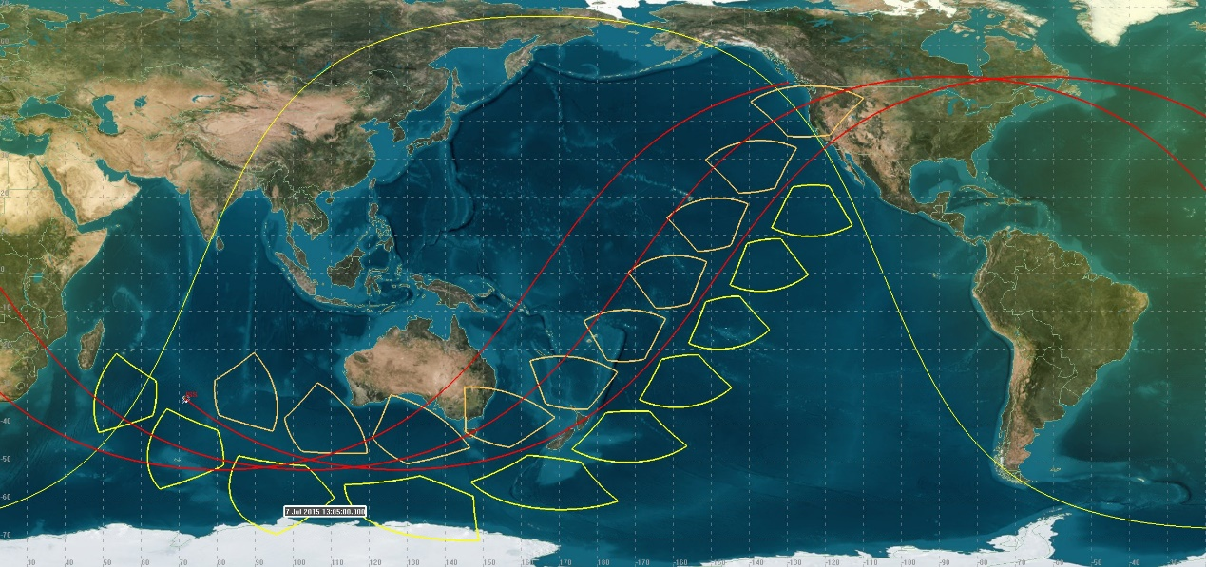
Time (UTCG) Detic.LLA.Latitude (deg) Detic.LLA.Longitude (deg)
------------------------ ------------------------ -------------------------
Orbit 4 night:
7 Jul 2015 13:05:00.000 -33.083 71.757
7 Jul 2015 13:10:00.000 -44.643 90.645
7 Jul 2015 13:15:00.000 -51.224 116.758
7 Jul 2015 13:20:00.000 -50.214 146.213
7 Jul 2015 13:25:00.000 -42.100 170.518
7 Jul 2015 13:30:00.000 -29.741 -172.152
7 Jul 2015 13:35:00.000 -15.342 -159.174
7 Jul 2015 13:40:00.000 -0.126 -148.076
7 Jul 2015 13:45:00.000 15.107 -136.984
Orbit 5:
7 Jul 2015 14:35:00.000 -26.236 40.862
7 Jul 2015 14:40:00.000 -39.279 56.831
7 Jul 2015 14:45:00.000 -48.739 79.258
7 Jul 2015 14:50:00.000 -51.738 108.087
7 Jul 2015 14:55:00.000 -46.889 135.763
7 Jul 2015 15:00:00.000 -36.307 156.368
7 Jul 2015 15:05:00.000 -22.730 171.172
7 Jul 2015 15:10:00.000 -7.810 -177.047
7 Jul 2015 15:15:00.000 7.506 -166.171
7 Jul 2015 15:20:00.000 22.464 -154.406

Orbits at 18:00Z
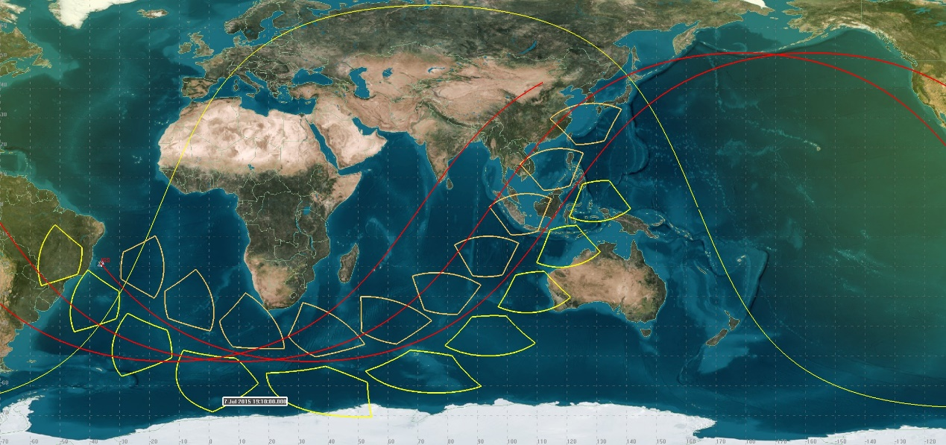
Time (UTCG) Detic.LLA.Latitude (deg) Detic.LLA.Longitude (deg)
------------------------ ------------------------ -------------------------
Orbit 6:
7 Jul 2015 19:10:00.000 -18.929 -36.193
7 Jul 2015 19:15:00.000 -32.986 -22.407
7 Jul 2015 19:20:00.000 -44.572 -3.566
7 Jul 2015 19:25:00.000 -51.201 22.496
7 Jul 2015 19:30:00.000 -50.250 51.961
7 Jul 2015 19:35:00.000 -42.179 76.321
7 Jul 2015 19:40:00.000 -29.841 93.694
7 Jul 2015 19:45:00.000 -15.451 106.694
7 Jul 2015 19:50:00.000 -0.239 117.798
7 Jul 2015 19:55:00.000 14.997 128.884
Orbit 7:
7 Jul 2015 20:45:00.000 -26.132 -53.285
7 Jul 2015 20:50:00.000 -39.193 -37.352
7 Jul 2015 20:55:00.000 -48.690 -14.980
7 Jul 2015 21:00:00.000 -51.745 13.822
7 Jul 2015 21:05:00.000 -46.949 41.538
7 Jul 2015 21:10:00.000 -36.398 62.196
7 Jul 2015 21:15:00.000 -22.836 77.032
7 Jul 2015 21:20:00.000 -7.921 88.826
7 Jul 2015 21:25:00.000 7.395 99.702
7 Jul 2015 21:30:00.000 22.358 111.454

Appendix 2 – Prioritized targets with observation instructions
THOR Observation Target List – Starting GMT 188 – 06:00
Refer to JEDI XX-XXXX for big picture words
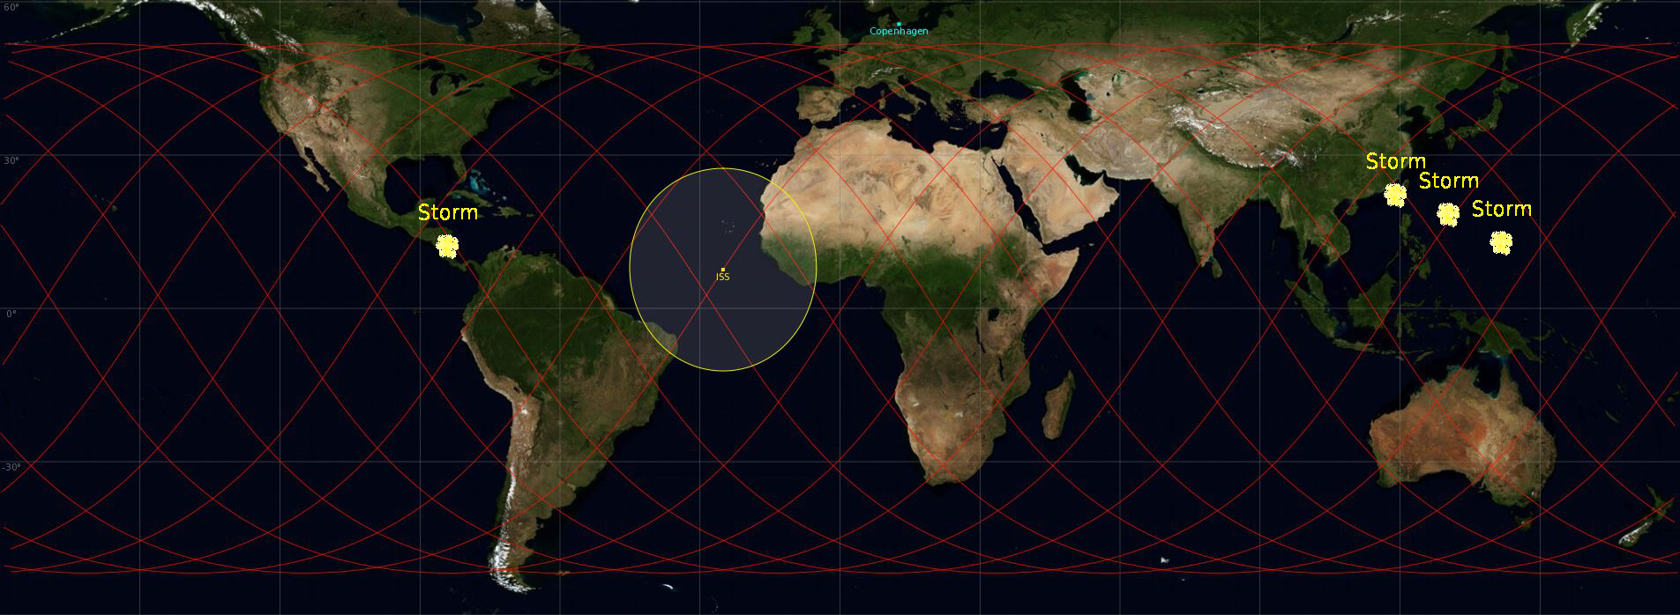

Particularities of today
E.g. none to report
or
e.g. Target 2 and target 3 have a small overlap
Target Summary
TARGET | Type / Config | Start | End | Start Pointing | Quality
1 | Cloud Turrets | 188/07:15 | 188/07:19 | Az: -33.4 º El -19.9 º | **
2 | TLEs | 188/08:07 | 188/08:11 | Az: -53.1 º El -19.9 º | **
3 | TLEs | 188/09:47 | 188/09:51 | Az: 89.8 º El -43.9 º | **
4 | TLEs | 188/17:25 | 188/17:29 | Az: -33.2 º El -20.0 º | ***
5 | TLEs | 188/18:58 | 188/19:03 | Az: -10.7 º El -20.1 º | ***
6 | TLEs | 188/19:05 | 188/19:09 | Az: 90.1 º El -27.5 º | ***
7 | Cloud Turrets | 188/19:39 | 188/19:44 | Az: 79.9 º El -24.5 º | **
8 | Cloud Turrets | 188/20:33 | 188/20:37 | Az: -1.8 º El -20.1 º | **
9 | TLEs | 188/20:39 | 188/20:44 | Az: 82.2 º El -22.5 º | ***
10 | Cloud Turrets | 188/21:12 | 188/21:17 | Az: -31.5 º El -19.9 º | **
11 | Cloud Turrets | 188/22:14 | 188/22:17 | Az: 80.2 º El -20.5 º | **
Click here for the detailed target list

General:
This message contains the upcoming THOR observation targets and will be updated daily. The target overview contains a summary (provided above) and a detailed target list (provided further down this document) of the upcoming observation possibilities. The storms are marked with asterisks to represent the quality.

Quick check-list
- Check Camera Time
- After observation session, downlink a minimum of three images
- Procedures
  - PODF 1.100 THOR D4 Time Set-Up
  - PODF 2.101 THOR CT Observations Day
  - PODF 2.201 THOR TLE Observations

Preparation

- Before starting the observation, make sure the camera time is set to the actual GPS time. How to set the time is described in PODF 1.100 THOR D4 Time SETUP.
- In case the equipment is stowed, please start preparing for the THOR activity 30 minutes before the predicted start time.
When the equipment is deployed, start preparing for the THOR activity 10 minutes before the predicted observation time.
- Make sure that everything is set-up 1 minute before the predicted start time.

At end of observation session

- After the observation, please make a minimum of three images available for downlink. The images can be selected at your preference.
- A reminder of upcoming THOR observations will be provided during the daily evening crew conference with Col-CC.
- Note that the THOR events are not in the OSTPV, only in the task list. If time becomes available please check the target list to see if any observations can be executed.

Pointing information:

Pointing direction in the ISS frame:
- Direction of velocity vector
- Perpendicular to velocity vector
- Nadir
==> Positive azimuth: turn right from velocity vector in the horizontal plane
==> Elevation is with respect to the horizontal plane

PORT: target comes from the horizon moving slowly and disappears underneath the ISS rapidly.
STBD: target comes rapidly in view from underneath the ISS and disappears slowly toward horizon (more difficult).

Detailed Target List

Target 1 | CTs above Taiwan | Quality **
Day  Start Time  End Time  ISS Site  Pointing | 2015/07/08 Daytime  188/07:15  188/07:19  Target on PORT side, coming from horizon  Start Az: -33.4 º El -19.9 º  End Az: -99.5 º El -24.0 º | 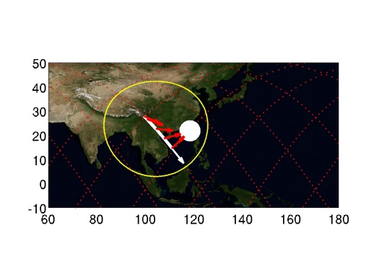

Target 2 | TLEs above Costa Rica | Quality **
Day  Start Time  End Time  ISS Site  Pointing | 2015/07/08 Night-time  188/08:07  188/08:11  Target on PORT side, coming from horizon  Start Az: -53.1 º El -19.9 º  End Az: -99.5 º El -20.5 º | 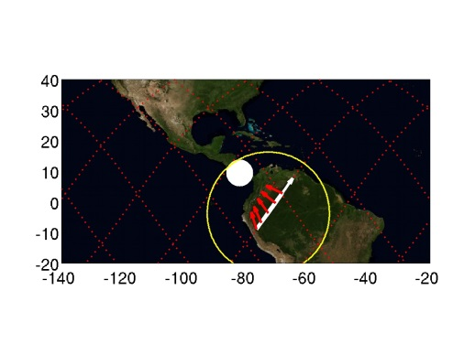

Target 3 | TLEs above Costa Rica | Quality **
Day  Start Time  End Time  ISS Site  Pointing | 2015/07/08 Night-time  188/09:47  188/09:51  Target on STBD side, moving toward horizon  Start Az: 89.8 º El -43.9 º  End Az: 167.0 º El -19.9 º | 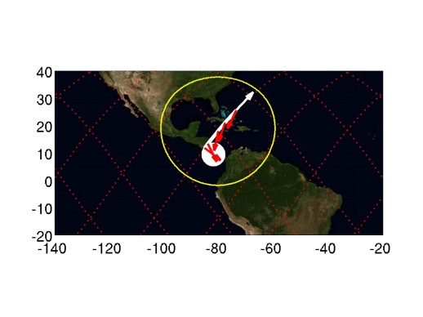

Target 4 | TLEs above Micronesia | Quality ***
Day  Start Time  End Time  ISS Site  Pointing | 2015/07/08 Night-time  188/17:25  188/17:29  Target on PORT side, coming from horizon  Start Az: -33.2 º El -20.0 º  End Az: -99.8 º El -24.3 º | 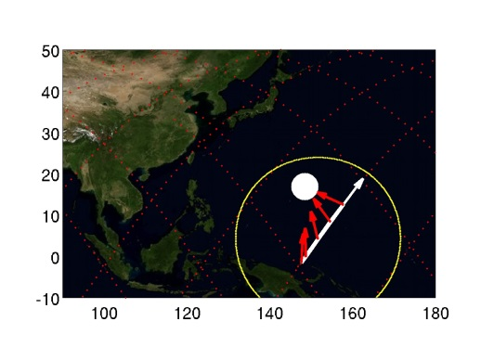

Target 5 | TLEs above Mariana Islands | Quality ***
Day  Start Time  End Time  ISS Site  Pointing | 2015/07/08 Night-time  188/18:58  188/19:03  Target on PORT side, coming from horizon  Start Az: -10.7 º El -20.1 º  End Az: -58.6 º El -45.1 º | 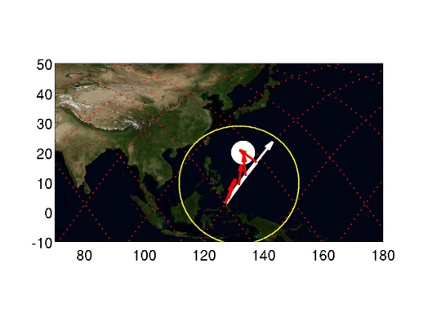

Target 6 | TLEs above Micronesia | Quality ***
Day  Start Time  End Time  ISS Site  Pointing | 2015/07/08 Night-time  188/19:05  188/19:09  Target on STBD side, moving toward horizon  Start Az: 90.1 º El -27.5 º  End Az: 150.5 º El -20.1 º | 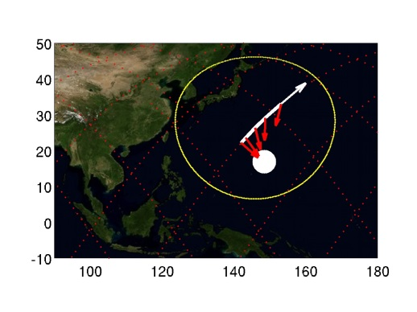

Target 7 | CTs above Costa Rica | Quality **
Day  Start Time  End Time  ISS Site  Pointing | 2015/07/08 Daytime  188/19:39  188/19:44  Target on STBD side, moving toward horizon  Start Az: 79.9 º El -24.5 º  End Az: 145.3 º El -20.1 º | 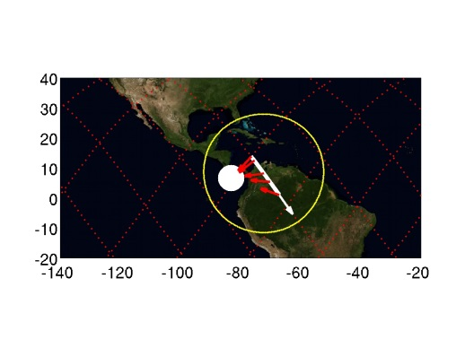

Target 8 | TLEs above Taiwan | Quality **
Day  Start Time  End Time  ISS Site  Pointing | 2015/07/08 Night-time  188/20:33  188/20:37  Target on PORT side, coming from horizon  Start Az: -1.8 º El -20.1 º  End Az: -7.3 º El -43.5 º | 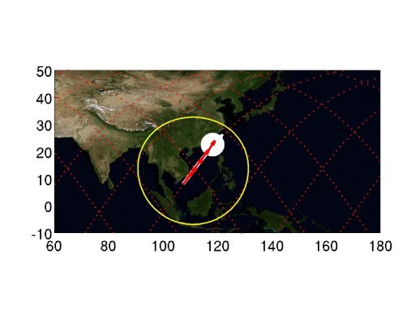

Target 9 | CTs above Mariana Islands | Quality ***
Day  Start Time  End Time  ISS Site  Pointing | 2015/07/08 Daytime  188/20:39  188/20:44  Target on STBD side, moving toward hori  Start Az: 82.2 º El -22.5 º  End Az: 141.1 º El -19.8 º | 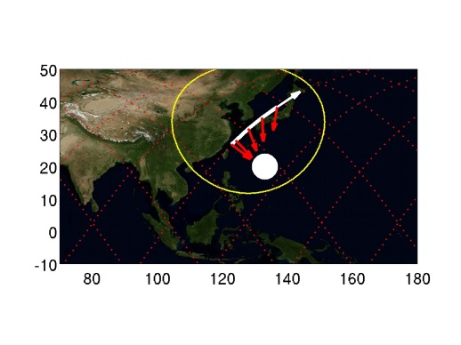

Target 10 | CTs above Costa Rica | Quality **
Day  Start Time  End Time  ISS Site  Pointing | 2015/07/08 Daytime  188/21:12  188/21:17  Target on PORT side, coming from horizon  Start Az: -31.5 º El -19.9 º  End Az: -100.7 º El -24.7 º | 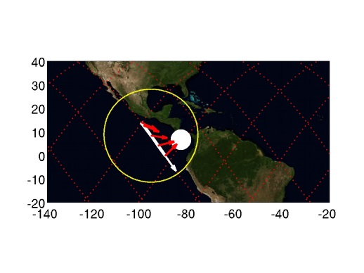

Target 11 | CTs above Taiwan | Quality **
Day  Start Time  End Time  ISS Site  Pointing | 2015/07/08 Daytime  188/22:14  188/22:17  Target on STBD side, moving toward horizon  Start Az: 80.2 º El -20.5 º  End Az: 124.6 º El -19.8 º | 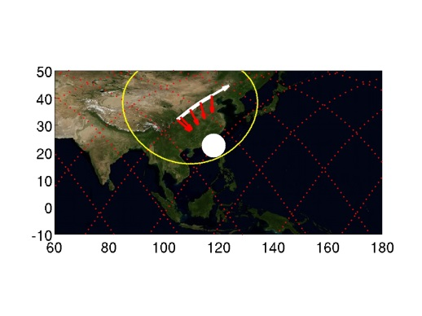

Target 12 | CTs above Taiwan | Quality **
Day  Start Time  End Time  ISS Site  Pointing | 2015/07/09 Daytime  189/06:20  189/06:25  Target on PORT side, coming from horizon  Start Az: -14.8 º El -19.9 º  End Az: -89.5 º El -39.7 º | 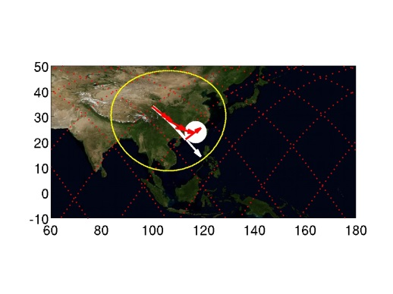

Target 13 | CTs above Mariana Islands | Quality ***
Day  Start Time  End Time  ISS Site  Pointing | 2015/07/09 Daytime  189/06:23  189/06:27  Target on PORT side, coming from horizon  Start Az: -44.3 º El -19.9 º  End Az: -102.8 º El -21.3 º | 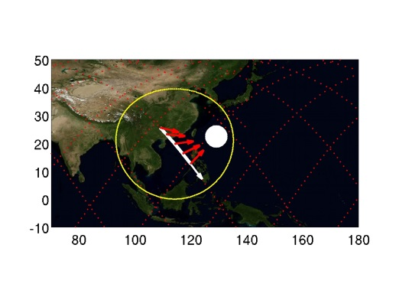

Target 14 | TLEs above Costa Rica | Quality **
Day  Start Time  End Time  ISS Site  Pointing | 2015/07/09 Night-time  189/08:48  189/08:52  Target on PORT side, coming from horizon  Start Az: -9.7 º El -20.0 º  End Az: -55.4 º El -46.8 º | 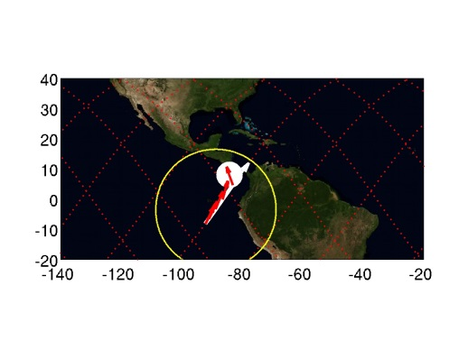

Target 15 | TLEs above Mariana Islands | Quality ***
Day  Start Time  End Time  ISS Site  Pointing | 2015/07/09 Night-time  189/18:06  189/18:11  Target on PORT side, coming from horizon  Start Az: -44.9 º El -19.9 º  End Az: -102.8 º El -21.4 º | 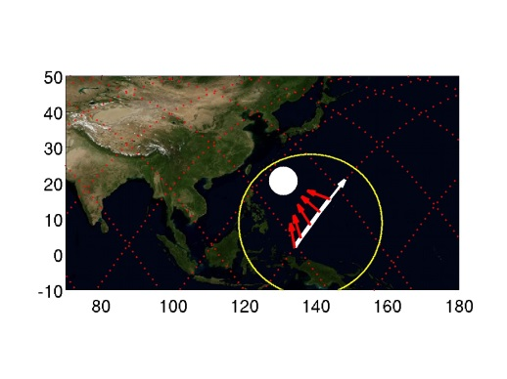

Target 16 | TLEs above Micronesia | Quality ***
Day  Start Time  End Time  ISS Site  Pointing | 2015/07/09 Night-time  189/18:12  189/18:16  Target on STBD side, moving toward horizon  Start Az: 126.7 º El -48.3 º  End Az: 170.1 º El -20.3 º | 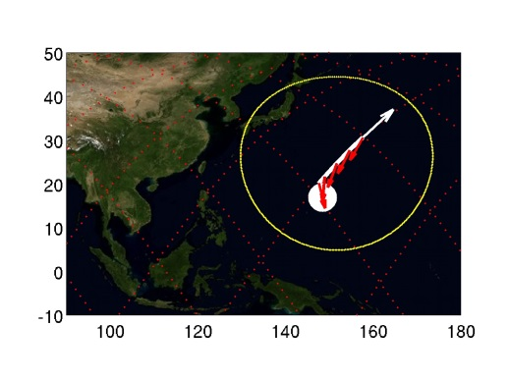

Target 17 | CTs above Costa Rica | Quality **
Day  Start Time  End Time  ISS Site  Pointing | 2015/07/09 Daytime  189/18:45  189/18:49  Target on STBD side, moving toward horizon  Start Az: 76.2 º El -20.2 º  End Az: 123.4 º El -19.9 º | 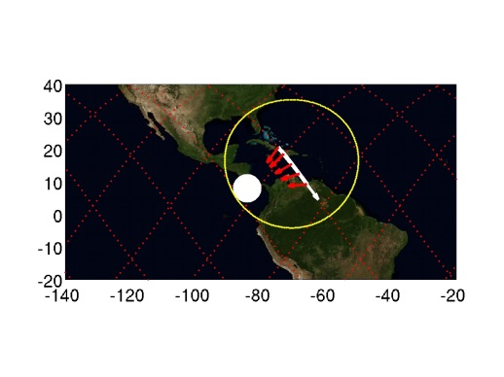

Target 18 | TLEs above Taiwan | Quality **
Day  Start Time  End Time  ISS Site  Pointing | 2015/07/09 Night-time  189/19:40  189/19:44  Target on PORT side, coming from horizon  Start Az: -25.2 º El -20.0 º  End Az: -90.2 º El -28.7 º | 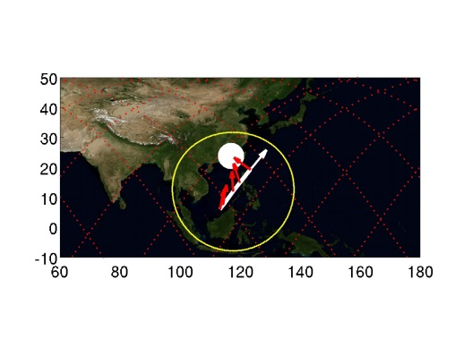

Target 19 | TLEs above Mariana Islands | Quality ***
Day  Start Time  End Time  ISS Site  Pointing | 2015/07/09 Night-time  189/19:46  189/19:50  Target on STBD side, moving toward horizon  Start Az: 134.1 º El -52.1 º  End Az: 172.3 º El -20.3 º | 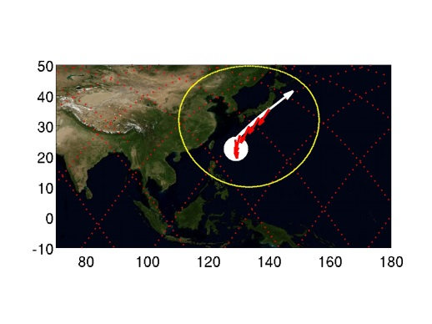

Target 20 | CTs above Costa Rica | Quality **
Day  Start Time  End Time  ISS Site  Pointing | 2015/07/09 Daytime  189/20:17  189/20:22  Target on PORT side, coming from horizon  Start Az: -10.8 º El -19.9 º  End Az: -60.3 º El -44.0 º | 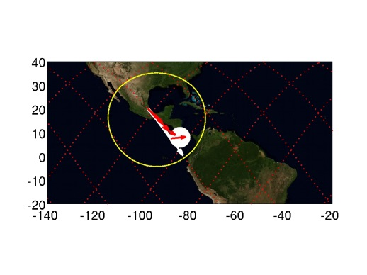

Target 21 | TLEs above Taiwan | Quality **
Day  Start Time  End Time  ISS Site  Pointing | 2015/07/09 Daytime  189/21:20  189/21:24  Target on STBD side, moving toward horizon  Start Az: 78.8 º El -25.8 º  End Az: 147.9 º El -20.0 º | 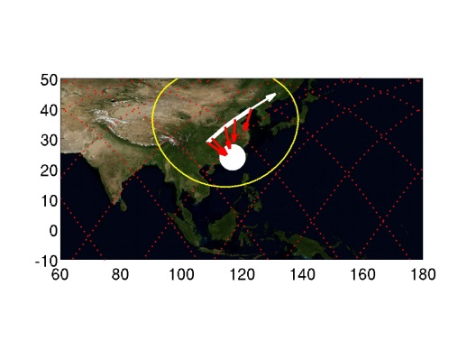

Target 22 | TLEs above Costa Rica | Quality **
Day  Start Time  End Time  ISS Site  Pointing | 2015/07/10 Night-time  190/07:55  190/07:59  Target on PORT side, coming from horizon  Start Az: -29.5 º El -20.0 º  End Az: -101.0 º El -25.8 º | 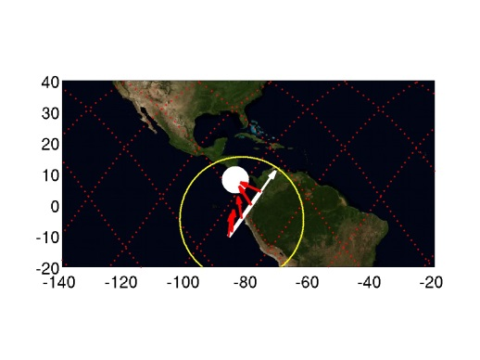

Target 23 | TLEs above Costa Rica | Quality **
Day  Start Time  End Time  ISS Site  Pointing | 2015/07/10 Night-time  190/09:35  190/09:39  Target on STBD side, moving toward horizon  Start Az: 80.2 º El -24.1 º  End Az: 143.2 º El -20.0 º | 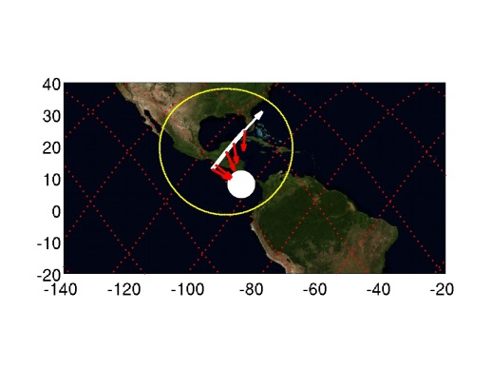

Target 24 | TLEs above Micronesia | Quality ***
Day  Start Time  End Time  ISS Site  Pointing | 2015/07/10 Night-time  190/17:13  190/17:17  Target on PORT side, coming from horizon  Start Az: -2.4 º El -20.1 º  End Az: -9.9 º El -43.2 º | 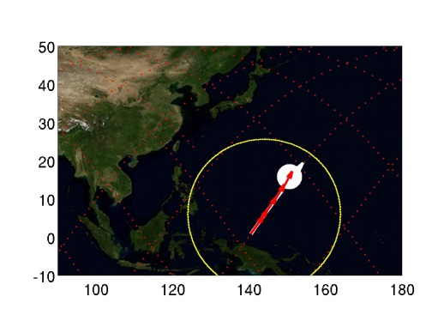

Target 25 | TLEs above Taiwan | Quality **
Day  Start Time  End Time  ISS Site  Pointing | 2015/07/10 Night-time  190/18:47  190/18:52  Target on PORT side, coming from horizon  Start Az: -45.0 º El -19.9 º  End Az: -102.9 º El -21.4 º | 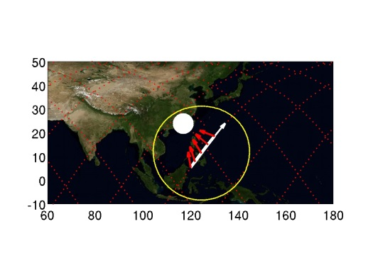

Target 26 | TLEs above Mariana Islands | Quality ***
Day  Start Time  End Time  ISS Site  Pointing | 2015/07/10 Night-time  190/18:47  190/18:51  Target on PORT side, coming from horizon  Start Az: -2.6 º El -20.1 º  End Az: -10.7 º El -43.2 º | 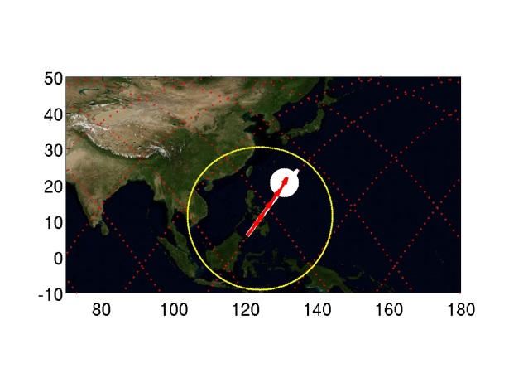

Target 27 | TLEs above Mariana Islands | Quality ***
Day  Start Time  End Time  ISS Site  Pointing | 2015/07/10 Night-time  190/18:54  190/18:58  Target on STBD side, moving toward horizon  Start Az: 79.1 º El -20.8 º  End Az: 127.4 º El -19.8 º | 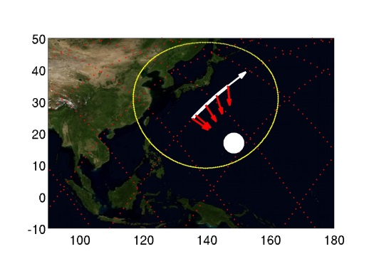

Target 28 | CTs above Costa Rica | Quality **
Day  Start Time  End Time  ISS Site  Pointing | 2015/07/10 Daytime  190/19:29  190/19:33  Target on STBD side, moving toward horizon  Start Az: 127.9 º El -48.8 º  End Az: 171.9 º El -20.0 º | 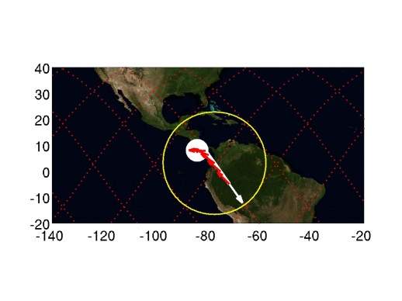

Target 29 | TLEs above Taiwan | Quality **
Day  Start Time  End Time  ISS Site  Pointing | 2015/07/10 Night-time  190/20:27  190/20:32  Target on STBD side, moving toward horizon  Start Az: 90.6 º El -43.5 º  End Az: 166.8 º El -19.9 º | 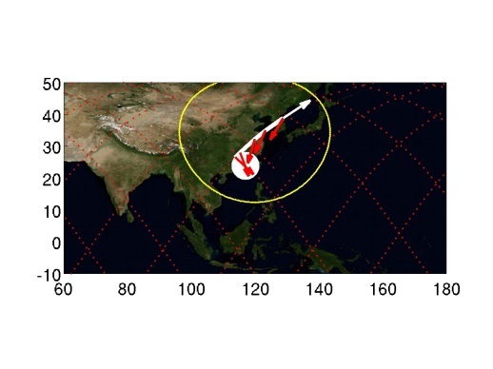

Target 30 | CTs above Micronesia | Quality ***
Day  Start Time  End Time  ISS Site  Pointing | 2015/07/10 Daytime  190/20:28  190/20:32  Target on STBD side, moving toward horizon  Start Az: 76.2 º El -20.3 º  End Az: 126.4 º El -19.8 º | 