Research Networking Programmes
Short Visit Grant or Exchange Visit Grant
Scientific Report

Proposal Title: New Frontiers in Millimeter / Sub-Millimeter Waves Integrated Dielectric Focusing Systems
Application Reference N°: 4492

- Purpose of the visit

In order to support the rapid growth of the MMW communication market [1], the silicon technology appears to be the most cost-effective and reliable solution for integrating digital base-band components and analog/RF circuits. Silicon-based RF CMOS and BiCMOS offering NMOS and SiGe HBT devices show respectively cut-off frequencies beyond 260 GHz and 300 GHz [2]. Low cost RFICs is not the only issue. Developing cost-effective integrated package antenna is also mandatory for addressing MMW applications. STMicroelectronics (ST) and the University Nice-Sophia Antipolis (UNS) started a fruitful collaboration in which a cost-effective package integration solution has been developed at 60 GHz. In order to evaluate several available packaging technologies, a measurement setup was developed for probe-fed antennas working in the V band (50-67 GHz) [3].
The development of low-cost antenna and package has been largely explored at 60 GHz and today the 60 GHz technology is deployed in consumer products [4].
Therefore, the research activity focuses today in higher frequency bands in the short MMW spectrum where broad bandwidths are available (20 GHz around 120 GHz and 80 GHz around 240 GHz). Developing applications around 120 GHz gives the opportunity to achieve ultra-high speed wireless communications while reducing the overall power consumption by simplifying the modulation scheme. Silicon technology has already demonstrated its capability for addressing the MMW spectrum [5]. Leveraging the V band measurement setup available, its capabilities have been recently extended to the F band in order to support the development of cost-effective integrated antennas. Using a lens could substantially increase the antenna gain of existing antenna-solutions in improving the link budget but a co-design with the feed antenna of the lens is necessary.
The purpose of this visit is to leverage the competences of the Instituto de Telecomunicações-Instituto Superior Técnico (IST-IT) team in the field of the MMW lenses on one hand and the competences of ST/UNS for the antenna design and characterization on the other hand, in order to develop specific lenses for addressing 120 GHz applications. The overall work plan is divided into two main steps.
In the first section, we will review the work carried out during this visit through two main projects. The first project focuses on the design of compact and directive lenses for low power 10 Gbps 10 m range wireless link at 120 GHz. The second project deals with the design of wide aperture lenses for medium range wireless link at 120 GHz. In the last section of the document we will present possible future collaborations between IST-IT, UNS, ST and the projected publications.

- Description of the work carried out during the visit

The project oriented activities enable to gain knowledge in some of the functionalities of the ILASH design and optimization software. ILASH is a powerful and user friendly software developed by the IST-IT team which is clearly described in [6, 7]. ILASH provides a complete solution for the design, optimization and analysis of shaped axial symmetric integrated lens antennas. This tool can handle single or double-shell lenses and the integrated lens source can be located at any position of the base of the lens or even inside the inner lens. The background theory of the lens surface design is based on the classical hybrid Geometrical Optics (GO)/Physical Optics (PO) procedure. As long as the lens dimensions are much larger than the operating wavelength, the GO design procedure is valid. Wavelength scale effects are not considered in the GO approach. The ILASH analysis tool enables checking the lens performances in terms of ray tracing, Fresnel coefficients and equivalent surface currents over the lens surface, and also computes near and far field radiation patterns.

Design of directive lenses for low power 10 Gbps 10 m range wireless link at 120 GHz

Specifications:
This study focuses on compact directive dielectric lenses at 120 GHz. This study is part of an overall larger project dedicated to 120 GHz high-speed communications. The system is intended to work over a large frequency bandwidth, to operate on a 10 m transmission distance, be low power, compact and cost effective. In order to comply with all those requirements, each component from the digital baseband to the MMW lens is carefully designed. The lens plays a key role at each end of the wireless link by improving the link budget in comparison to the system without the lens, and helping in reducing the power consumption etc. A co-design with the feed antenna was necessary to optimize the overall performances and to provide a low-profile solution.
The broad bandwidth available around 120 GHz is of strong interest for addressing ultra-high speed communications. The targeted frequency bandwidth ranges from 116 GHz to 142 GHz, representing more than 20 GHz. Such a huge bandwidth allows to target 10 Gbps data rate using a simple OOK modulation scheme [8]. Since the modulation scheme is simple, there is no need for power hungry digital baseband circuits.
A transmission distance of 10m is targeted. The path loss attenuation at 140 GHz over 10 m is equal to 95 dB. Using transceivers with TX output power of 0 dBm and RX sensitivity of -35 dBm, a 30 dBi antenna gain is required to fulfill those 10m (lens with feed).
The final prototype will have to be as compact as possible. The lens size is related to the maximum wanted directivity. In order to obtain a low profile lens solution, the maximum radiation efficiency is obtained with an optimized source which in fact produces the optimized angular illumination of the lens.
Various materials have already been explored for lenses at MMW like Polyethylene [9], Rexolyte [10], Alumina [11] and Quartz [12] but so far, from our best knowledge, never classical ABS-M30 material (consumer grade plastic used for smartphone casing). Using 3D printing technology allows rapid manufacturing. Plastic based 3D printers are eventually becoming more and more popular.
In order to predict the lens performances, accurate permittivity characterization is required. The IST-IT team previously designed an open Fabry-Perot resonator [13] which allows characterizing complex permittivity value of any material with at least 1 % accuracy up to 67 GHz. This complex permittivity measurement system also enables checking the material isotropy which is of crucial importance to not deform the expected radiation pattern shape of the lens. Therefore, during the mission, we performed ABS-M30 plastic measurements at 60 GHz: average relative permittivity of 2.48 and $\tan{δ}$ of 0.008 were extracted. Based on these values and on the fact that the isotropy ABS-30 plastic material has been verified, this dielectric material seems to be appealing for MMW applications.

Lens design and analysis:
In order to comply with 30 dBi gain over 26 GHz bandwidth at 130 GHz, an elliptical lens with optimized extended length was designed in ILASH. First, the lens was optimized with a gaussian beam feed pre-defined in ILASH.
Based on classical GO/PO analysis combination, ILASH includes several tools for checking the good lens behavior before fabrication such as ray analysis, maps of the Fresnel Coefficients over the lens surface, equivalent surface currents, near field and far field. Ray analysis tool performs a ray tracing in the forward direction. As this study addresses collimated beam lens design, this ray tracing analysis enables to visually check rays direction outside the lens. Surface currents tool provides a 3D representation of the equivalent surface currents distribution over the lens surface. This analysis allows checking internal reflections to avoid any surface wave propagation over the lens surface. Fig. 1 presents two output windows from ILASH showing the ray tracing inside and outside the length as well as the equivalent surface currents at 130 GHz over the designed elliptic lens surface.
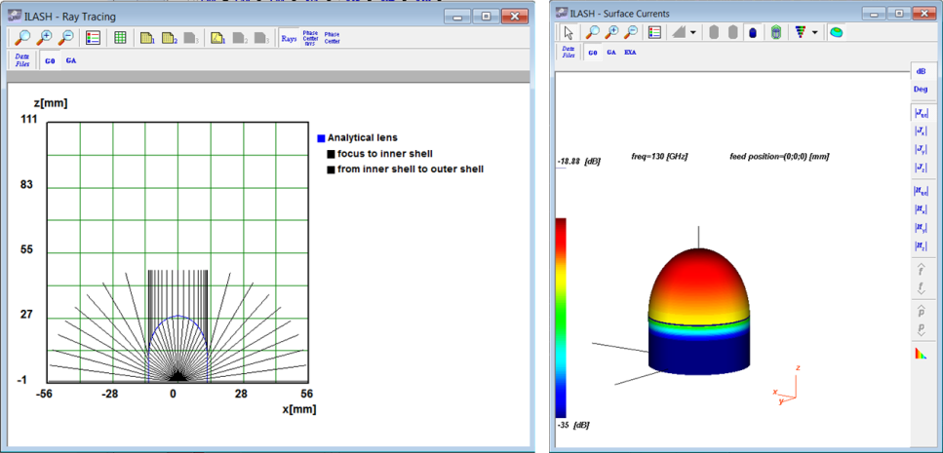

(a) (b)
Figure 1: Ray tracing at 130 GHz (a) 3D plot of the equivalent surface currents at 130 GHz (b)

Lens and Feed co-design
In order to leverage the radiation efficiency of the lens, a co-design between the lens and the feed is mandatory. As the ILASH design tool allows adjusting the feed aperture angle, the impact of the feed directivity versus the lens directivity was studied. Based on this parametric study presented in Fig 1(a), an optimum operation point for the smallest lens with directivity of 30 dBi was found for a feed directivity of 12.8 dBi and a lens diameter of 25 mm. The lens main dimensions are represented in the geometric view in Fig 2(b). The optimum extension length is calculated by ILASH software: 11.18 mm. The feed antenna half-power beamwidth corresponding to the 12.8 dBi of directivity is of 40 °.
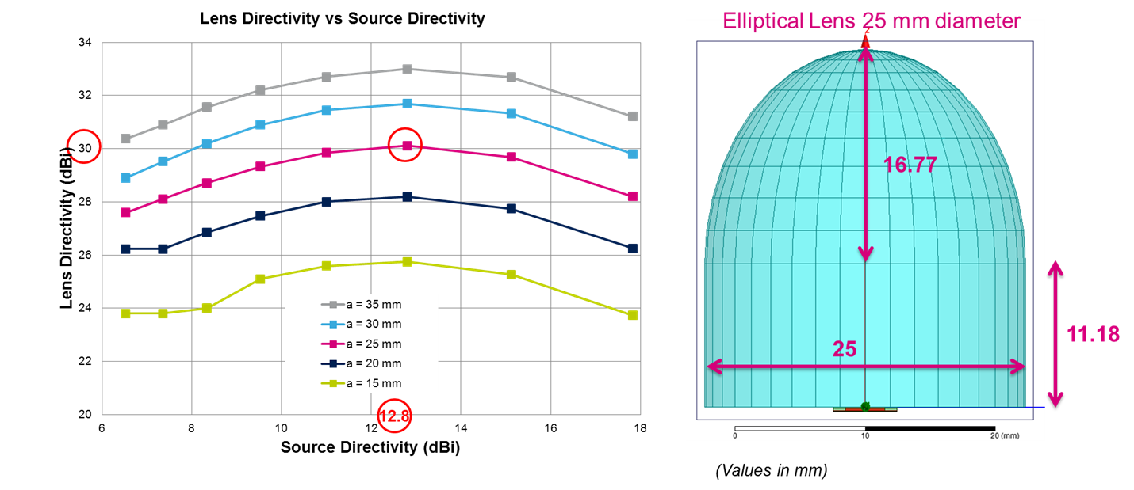
- (b)
Figure 2: Lens Directivity versus Source directivity with the lens diameter parameterized (a) Lens final design main dimensions (circle point in Fig. 2a) (b)

Based on this study, a feed antenna was designed in the HDI organic technology developed by ST [14]. The antenna final layout is presented in Fig 3(b). This topology is based on an array of four linearly-polarized aperture-coupled patch (LACP) structures surrounded by a metallic cavity ring. This feed structure allows to properly adjusting the aperture angle in each plane. The parameters c and d (Figure 3b) enable to adjust the aperture angle targeted in each plane. The specifications in terms of matching (S₁₁) bandwidth and directivity have been all reached with fine optimization. The optimization process of the feed antenna has been led with HFSS EM Finite Element Method (FEM) simulator. The huge size of the lens (~10 λ₀) is an issue for any full-wave simulator based on the discretization of the entire volume to be analyzed. In order to alleviate the computing simulation resources, the feed was optimized with several simulation steps represented in Fig 3(a) in order to mimic radiation in the base of the lens. Those simulation configurations do not take into account the internal reflections of the waves within the lens but constitute a very realistic and fair approximation of the radiation of the source in the lens.
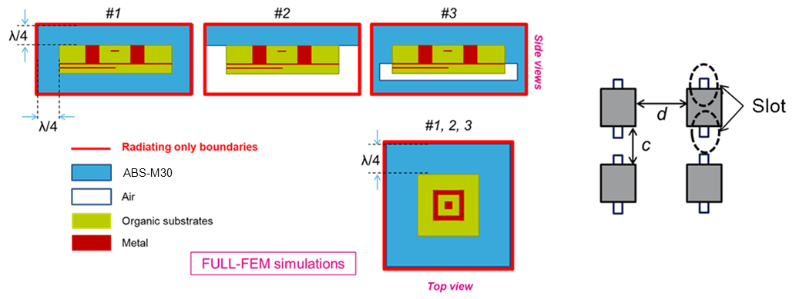
- (b)

Figure 3: Feed Simulation configurations (a) Feed antenna topology (b)

The combined lens and feed performances are presented in the last section of this document.

Design of beam-shaped lenses for wireless link at 120 GHz
The motivation here is to develop high-speed wireless links at 120 GHz for medium range communications. As presented in Fig 4, the typical use-case targeted is a wireless link between a fixed MMW base-station and a user seated on a sofa. From the antenna side, there is a challenging compromise to find between a wide aperture antenna in order to guaranty the user experience, and a high gain in order to achieve medium range transmission. Generally, this problem is solved with beam forming implementation. However, this approach leads to more complex systems at the expense of an increase in the overall power consumption of the chipset. In this application, a wide aperture is mandatory in the horizontal plane whereas the needed vertical coverage is narrow. This type of coverage was already achieved at lower frequencies [15-16-17]. Here we propose a design procedure combining ILASH and a full-wave simulator.
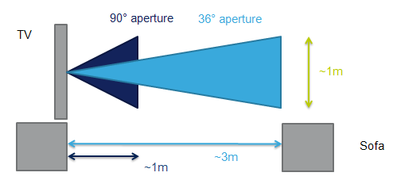
Figure 4: Targeted use case.

The optimized lens geometry is represented in Fig 5. The lens has no axis of symmetry. As ILASH only allows axial symmetry lens shape, the design procedure was divided in two steps regarding each lens profile [18]. The lens geometry combines a non-collimated beam lens for the horizontal profile whereas the vertical profile requires a collimated beam.
For non-collimated lenses, ILASH enables designing shaped profiles to satisfy different types of shaped output beam specifications. Here we selected the Amplitude template option (single shell) shaped lens. By importing the radiation pattern template targeted, ILASH allowed calculation of the lens shape accordingly. For the radiation pattern targeted in the horizontal plane, 160 ° of aperture angle is expected. Figure 6 (a) provides the ray tracing for the horizontal lens profile.
The vertical profile is calculated by ILASH defining an extended hemispherical lens with adjusted focal point. 40° of aperture angle is targeted in the vertical plane. Figure 5 (b) presents the ray tracing for the vertical lens profile.
A single feed was used, based on the previous array configuration. Once each lens profile was correctly tuned to match the specifications in each plane, the final lens profile was built and simulated with a full-wave simulator.
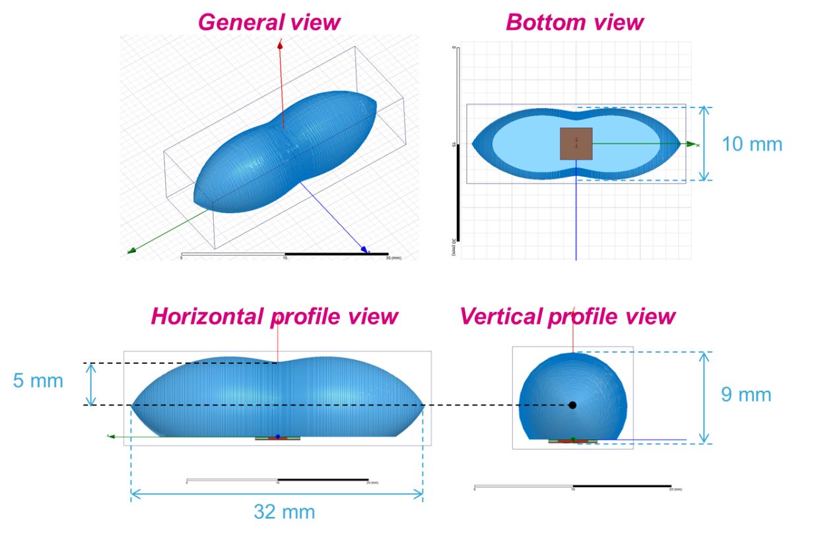
Figure 5: Lens geometry and main dimensions

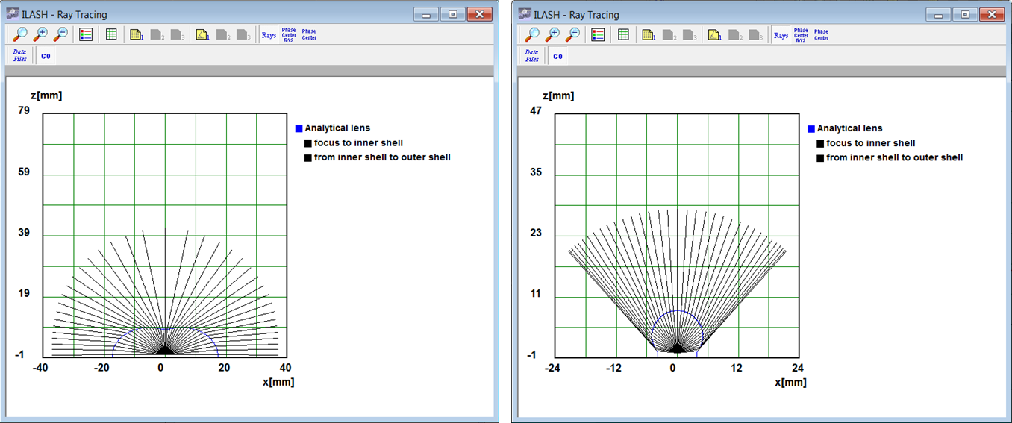
- (b)
Figure 6: Ray analysis in the horizontal (a) profile and vertical (b) profile

The combined lens and feed performances are presented in the last section of this document.

- Description of the main results obtained

Design of directive lenses for low power 10 Gbps 10 m range wireless link at 120 GHz
By presenting the directivity, IEEE and realized gains of the overall structure combining the lens and the feed, Fig. 7 provides a brief overview of the simulated performances with the Ansoft HFSS full-wave simulator. Those results almost match all our specifications. There are still final adjustments to perform on the feed design but this lens and feed co-design approach is almost done.

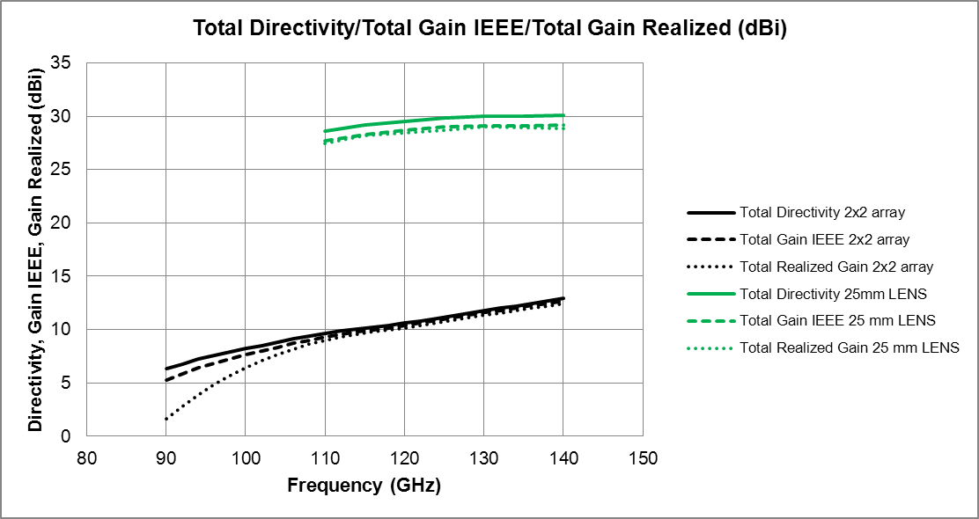
Figure 7: Lens with Feed Directivity and Gains (green) superposed with Feed Directivity and Gains (black)

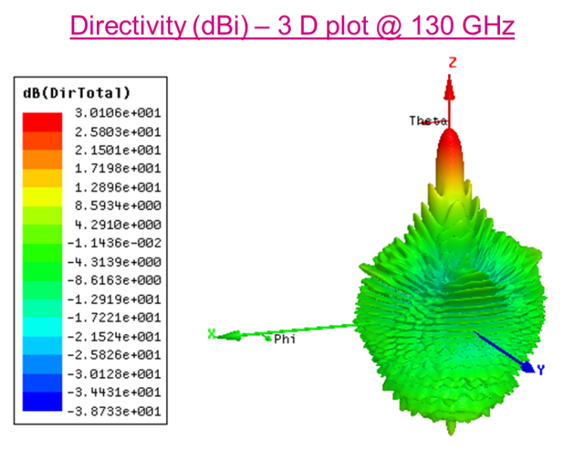
Figure 8: 3D radiation pattern of the Lens directivity at 130 GHz

Design of beam shaped lenses for wireless link at 120 GHz
The 3D radiation pattern shape presented in Fig. 9 and the realized gain in cut planes presented in Fig. 10 demonstrate that all specifications in terms of aperture are almost reached. There is still a final optimization to perform on the feed source in order to increase the lens radiation efficiency over the frequency bandwidth.
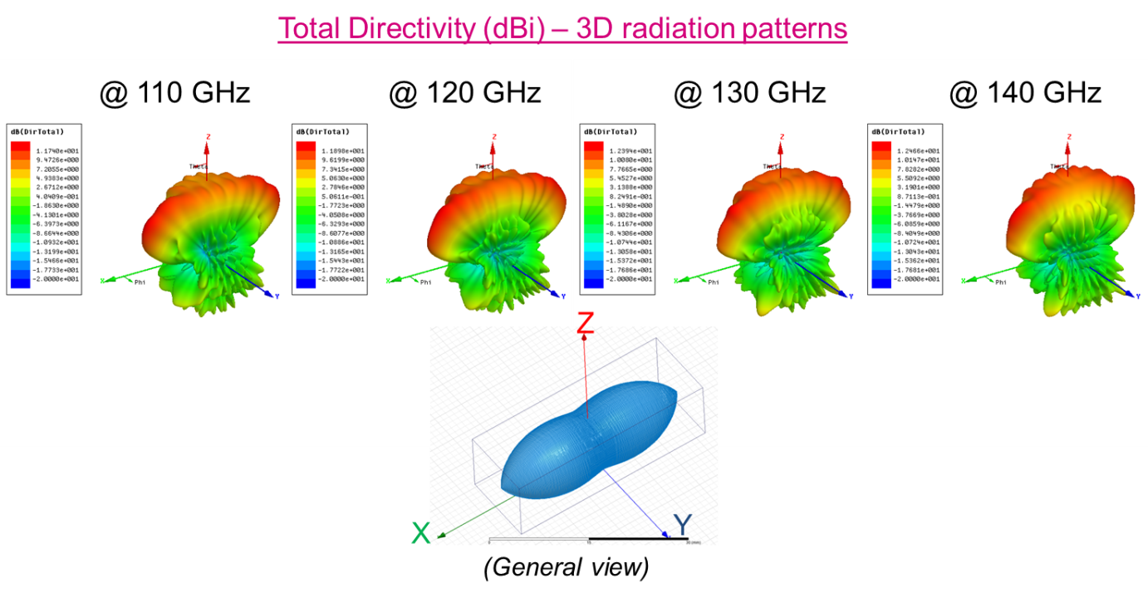
Figure 9: 3D radiation patterns of the lens directivity according to frequency

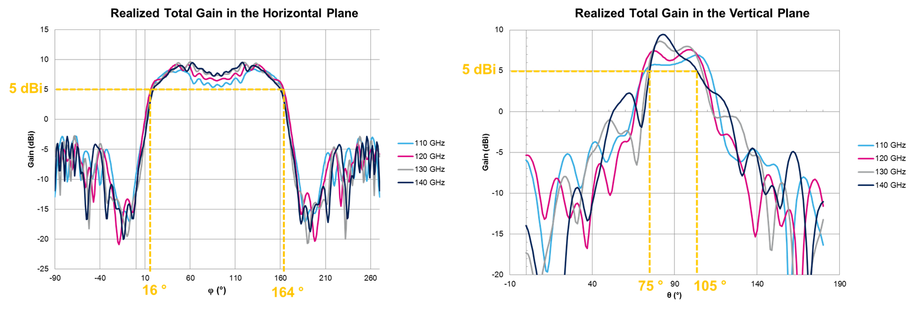
Figure 10: Realized Total Gain in the horizontal and vertical planes according to frequency

- Future collaboration with host institution (if applicable)

Up to now, only simulation results have been achieved within each project. These lenses will be soon fabricated in plastic ABS-30 material with a 3D printer beginning of 2014. Once the lenses and the feed antenna will be fabricated, they will be tested with the F band 3D measurement setup of probe-fed antennas from UNS. These passive measurements will be conducted as soon as the prototypes are ready to be tested.
These designs are part of a larger project which will lead to the RFIC design starting in March 2014. The system measurements are scheduled one year later in 2015. STMicroelectronics will provide the necessary equipment to perform these system measurements.

- Projected publications / articles resulting or to result from the grant (ESF must be acknowledged in publications resulting from the grantee’s work in relation with the grant)

Publications are projected along the projects life cycle. Short terms publications in conferences like IMS, AP-S, RFIC are targeted as well as longer terms publications in the ISSCC conference and in journals like IEEE Transactions on Antennas and Propagation, IEEE Antennas and Wireless Propagation letters, IEEE Microwave and Wireless Components Letters and IEEE Microwave Theory and Techniques.

- Other comments (if any)

By gathering the competences of IST-IT on one side and the competences of ST/UNS on the other side, this visit allowed us to make significant progress within each project. The knowledge for the lens design and the use of ILASH software will be transferred to ST and UNS in order to support future projects. This visit is the beginning of a stronger collaboration between IST-IT and ST/UNS which will probably lead to new Short Term Scientific Missions within the COST IC1102. IST-IT research team will be welcomed to visit UNS within the frame of the COST IC1102 on “Versatile, Integrated, and Signal-aware Technologies for Antennas (VISTA)”.

[1] www.cisco.com (Visual Networking Index)
[2] P. Chevalier, F. Pourchon, T. Lacave, G. Avenier, Y. Campidelli, L. Depoyan, G. Troillard, M. Buczko, D. Gloria, D. Ceoli, C. Gaquiere, A. Chantre, “A conventional double-polysilicon FSA-SEG Si/SiGe HBT reaching 400GHz Fmax”, IEEE Bipolar/BiCMOS Circuits and Technology Meeting, 2009, BCTM 2009, pp. 1-4, 2009.
[3] D. Titz, F. Ferrero, C. Luxey, “Development of a Millimeter-Wave Measurement Setup and Dedicated Techniques to Characterize the Matching and Radiation Performance of Probe-Fed Antennas”, IEEE Antennas and Propagation Magazine, Vol. 54, pp. 188-203, 2012.
[4] www.wilocity.com
[5] E. Laskin, P. Chevalier, A. Chantre, B. Sautreuil, S.P. Voinigescu, “165-GHz Transceiver in SiGe Technology”, IEEE Journal of Solid-State Circuits, Vol. 43, pp. 1087-1100, 2008.
[6] www.it.pt/auto_temp_web_page_preview.asp?id=275
[7] E. Lima, J. R. Costa, M. G. Silveirinha, C. A. Fernandes, “ILASH – Software tool for the design of integrated lens antennas”, IEEE Antennas and Propagation Society International Symposium, pp. 1-4, AP-S 2008.
[8] H.Zhongxia, T. Swahn, L. Yinggang, H. Zirath, “A 14-Gbps On-/Off- Keying Modulator in GaAs HBT Technology”, IEEE Microwave and Wireless Components Letters, Vol. 22, pp. 272-274, 2012.
[9] J. R. Costa et al., “Compact Beam-Steerable Double-Shell Lens Antenna for 60-GHz Wireless Communications”, IEEE Transactions on Antenna and Propagation, Vol. 57, No. 10, pp. 2926-2933, October 2009.
[10] N. T. Nguyen et al., “Reduced-Size Double-Shell Lens Antenna With Flat-Top Radiation Pattern for Indoor Communications at Millimeter Waves“, IEEE Transactions on Antenna and Propagation, Vol. 59, No. 6, pp.2424-2429, June 2011.
[11] N. T. Nguyen et al., “Design and Characterization of 60-GHz Integrated Lens Antennas Fabricated Through Ceramic Stereolithography », IEEE Transactions on Antenna and Propagation, Vol. 58, No. 8, pp. 2757-2762, August 2010
[12] A. Artemenko et al., “Millimeter-Wave Electronically Steerable Integrated Lens Antenna for WLAN/WPAN Applications“, IEEE Transactions on Antenna and Propagation, Vol. 61, No. 4, pp.1665, April 2013.
[13] C. A. Fernandes and J. R. Costa, “Permittivity Measurement and Anisotropy Evaluation of Dielectric Materials at Millimeter-Waves”, XIX IMEKO World Congress Fundamental and Applied Metrology, September 6-11 2009, Lisbon, Portugal.
[14] R. Pilard, D. Titz, F. Gianesello, P. Galascibetta, J.M. Riviere, J. Lopez, R. Coffry, E. Saugier, A. Poulain, F. Ferrero, C. Luxey, P. Brachat, G. Jacquemod, D. Gloria, “HDI organic technology integrating build-in antennas dedicated to 60 GHz SiP solution”, IEEE Antennas and Propagation Society International Symposium (APSURSI), 2012.
[15] J. R. Costa, C. A. Fernandes, G. Godi, R. Sauleau, L. Le Coq, H. Legay, “Compact Ka-Band Lens Antennas for LEO Satellites”, IEEE Transactions on Antennas and Propagation Magazine, Vol. 56, No. 5, pp. 1251-1258, 2008.
[16] C. A. Fernandes, J. G. Fernandes, “Performance of Lens Antenans in Wireless Indoor Millimeter-Wave Applications”, IEEE Transactions on Microwave Theory and Techniques, Vol. 47, No. 6, pp. 732-737, 1999.
[17] C. A. Fernandes, “Shaped Dielectric Lenses for Wireless Millimeter-Wave Communications”, IEEE Antennas and Propagation Magazine, Vol. 41, No. 5, 1999.
[18] C. A. Fernandes, “Design of shaped lenses for non-symmetric cells in MBS”, IEEE Antennas and Propagation Society International Symposium, pp. 2440-2443, AP-S 1999.

